FCFF and FCFE are two types of cash flows used in financial analysis to determine a company's ability to generate cash.

FCFF stands for "Free Cash Flow to the Firm" and represents the amount of cash available to all providers of capital, including both equity and debt holders. It is calculated as EBIT (earnings before interest and taxes) multiplied by (1 - tax rate) plus depreciation and amortization expenses less capital expenditures and changes in working capital.

FCFE, on the other hand, stands for "Free Cash Flow to Equity" and represents the amount of cash available to equity holders after all expenses have been paid, including both interest payments and principal repayments on debt. It is calculated as net income minus any mandatory debt repayments plus depreciation and amortization expenses less capital expenditures and changes in working capital.

In summary, FCFF is the cash flow available to all capital providers, while FCFE is the cash flow available only to equity holders.

Certainly, here are the mathematical formulas for calculating FCFF and FCFE:

FCFF = EBIT*(1 - tax rate) + Depreciation and Amortization - Capital Expenditures - Changes in Working Capital

Where:

* EBIT = Earnings Before Interest and Taxes
* Tax Rate = the corporate tax rate
* Depreciation and Amortization = non-cash expenses related to the use of fixed assets and intangible assets
* Capital Expenditures = the amount spent on new or existing fixed assets
* Changes in Working Capital = the difference between the current and previous period's working capital (current assets minus current liabilities)

FCFE = Net Income - Mandatory Debt Repayments + Depreciation and Amortization - Capital Expenditures - Changes in Working Capital

Where:

* Net Income = total revenue minus total expenses
* Mandatory Debt Repayments = any principal payments on outstanding debt
* Depreciation and Amortization = non-cash expenses related to the use of fixed assets and intangible assets
* Capital Expenditures = the amount spent on new or existing fixed assets
* Changes in Working Capital = the difference between the current and previous period's working capital (current assets minus current liabilities)
* When a firm's objective is to maximize its value, it means that the primary goal of the firm is to increase the wealth of its owners, who are the shareholders. The value of a firm is determined by the market price of its shares, which is based on investors' expectations of the firm's future earnings and cash flows.
* Maximizing the value of a firm means making decisions that increase the market price of its shares over the long-term. This can involve making investments that generate positive net present value (NPV) by earning a rate of return greater than the cost of capital, optimizing the capital structure to minimize the cost of capital, and improving operational efficiency to increase profitability.
* Focusing on maximizing shareholder value can align the interests of management with those of shareholders, as both parties benefit from increases in the market price of shares. However, it can also lead to short-term decision-making at the expense of long-term value creation, as managers may prioritize short-term gains or pursue strategies that increase the market price of shares in the short-term but harm the firm's long-term prospects.

**What Is the Traditional Theory of Capital Structure?**

The traditional theory of capital structure states that when the [weighted average cost of capital (WACC)](https://www.investopedia.com/terms/w/wacc.asp) is minimized, and the [market value](https://www.investopedia.com/terms/m/marketvalue.asp) of assets is maximized, an optimal structure of capital exists. This is achieved by utilizing a mix of both equity and debt capital. This point occurs where the marginal cost of debt and the marginal cost of equity are equated, and any other mix of debt and equity financing where the two are not equated allows an opportunity to increase firm value by increasing or decreasing the firm’s leverage.

KEY TAKEAWAYS

* The traditional theory of capital structure says that for any company or investment there is an optimal mix of debt and equity financing that minimizes the WACC and maximizes value.
* Under this theory, the optimal capital structure occurs where the marginal cost of debt is equal to the marginal cost of equity.
* This theory depends on assumptions that imply that the cost of either debt or equity financing vary with respect to the degree of leverage. Te haces mas riesgoso entonces los acreedores piden mas tasa para compensar ese riesgo. En el caso del costo de los shareholders, el aumento del rendimiento tiene que ver también con la empresa siendo mas riesgosa. Ceteris paribus, un accionista prefiere un rendimiento mas grande respecto de una empresa menos apalancada.

**Understanding the Traditional Theory of Capital Structure**

The traditional theory of [capital structure](https://www.investopedia.com/terms/c/capitalstructure.asp) says that a firm's value increases to a certain level of debt capital, after which it tends to remain constant and eventually begins to decrease if there is too much borrowing. This decrease in value after the debt tipping point happens because of overleveraging. On the other hand, a company with zero leverage will have a WACC equal to its cost of equity financing and can reduce its WACC by adding debt up to the point where the marginal cost of debt equals the marginal cost of equity financing. In essence, the firm faces a trade-off between the value of increased leverage against the increasing costs of debt as borrowing costs rise to offset the increase value. Beyond this point, any additional debt will cause the market value and to increase the cost of capital. A blend of equity and debt financing can lead to a firm's [optimal capital structure](https://www.investopedia.com/terms/o/optimal-capital-structure.asp).

The traditional theory of capital structure tells us that wealth is not just created through investments in assets that yield a positive return on investment; purchasing those assets with an optimal blend of [equity](https://www.investopedia.com/terms/e/equity.asp) and debt is just as important. Several assumptions are at work when this theory is employed, which together imply that the cost of capital depends upon the degree of leverage. For example, there are only debt and equity financing available for the firm, the firm pays all of its earnings as a dividend, the firm's total assets and revenues are fixed and do not change, the firm's financing is fixed and does not change, investors behave rationally, and there are no taxes. Based on this list of assumptions, it is probably easy to see why there are several critics.

The traditional theory can be contrasted with the [Modigliani and Miller (MM)](https://www.investopedia.com/terms/m/modigliani-millertheorem.asp) theory, which argues that [if financial markets are efficient](https://www.investopedia.com/terms/e/efficientmarkethypothesis.asp), then debt and equity finance will be essentially interchangeable and that other forces will indicate the optimal capital structure of a firm, such as corporate tax rates and tax deductibility of interest payments.

Discounting cash flows by the cost of money is necessary because it accounts for the time value of money, which is the concept that money available at the present time is worth more than the same amount of money in the future, due to its earning potential.

When we discount future cash flows, we are reducing their value by a rate that reflects the opportunity cost of investing that money elsewhere. This rate is called the cost of capital or the discount rate, and it represents the minimum rate of return that an investor requires to invest their money in a particular project or asset.

Discounting cash flows by the cost of capital allows us to compare the value of cash flows that occur at different points in time, and determine whether an investment is worth undertaking or not. For example, if we have two investment opportunities with different cash flows, discounting them back to the present using the cost of capital enables us to compare their present values and determine which investment provides a higher return.

In summary, discounting cash flows by the cost of money is necessary to account for the time value of money and to compare cash flows occurring at different points in time. By discounting future cash flows back to their present value, we can determine whether an investment opportunity is worth pursuing or not.

The concept of discounting cash flows by the cost of money is closely related to the Weighted Average Cost of Capital (WACC). WACC is a financial metric that represents the average cost of capital for a company, taking into account the cost of both equity and debt financing.

Yes, the general formula for discounting cash flows is as follows:

PV = CF / (1 + r)^n

Where: PV = present value of cash flows CF = cash flow in a given period r = discount rate (i.e., cost of capital) n = number of periods into the future the cash flow occurs

This formula calculates the present value of a future cash flow by dividing the cash flow by a discount factor, which is calculated by raising the discount rate plus 1 to the power of the number of periods into the future that the cash flow occurs.

For example, if you have a cash flow of $1,000 that will occur three years from now and a discount rate of 10%, the present value of the cash flow would be calculated as follows:

PV = $1,000 / (1 + 0.10)^3 PV = $751.31

This means that the cash flow of $1,000 three years from now is worth $751.31 today, assuming a 10% discount rate.

**What Is Weighted Average Cost of Capital (WACC)?**

Weighted average cost of capital (WACC) represents a firm’s average after-tax [cost of capital](https://www.investopedia.com/terms/c/costofcapital.asp) from all sources, including common stock, preferred stock, bonds, and other forms of debt. WACC is the average rate that a company expects to pay to finance its assets.

WACC is a common way to determine [required rate of return (RRR)](https://www.investopedia.com/terms/r/requiredrateofreturn.asp) because it expresses, in a single number, the return that both bondholders and shareholders demand to provide the company with [capital](https://www.investopedia.com/terms/c/capital.asp). A firm’s WACC is likely to be higher if its [stock](https://www.investopedia.com/terms/s/stock.asp) is relatively volatile or if its debt is seen as risky because investors will require greater returns.

KEY TAKEAWAYS

* Weighted average cost of capital (WACC) represents a firm’s cost of capital where each category of capital is proportionately weighted.
* WACC is commonly used as a [hurdle rate](https://www.investopedia.com/terms/h/hurdlerate.asp) against which companies and investors can gauge the desirability of a given project or acquisition.
* WACC is calculated by multiplying the cost of each capital source (debt and equity) by its relevant weight by market value, then adding the products together to determine the total.
* WACC is also used as the discount rate for future cash flows in discounted cash flow analysis.

WACC is the [discount rate](https://www.investopedia.com/terms/d/discountrate.asp) that a company uses to estimate its [net present value](https://www.investopedia.com/terms/n/npv.asp).

WACC is also important when analyzing the potential benefits of taking on projects or acquiring another business.

As the majority of businesses run on borrowed funds, the cost of capital becomes an important parameter in assessing a firm’s potential for net profitability. WACC measures a company’s cost to borrow money.

In most cases, a lower WACC indicates a healthy business that’s able to attract investors at a lower cost.

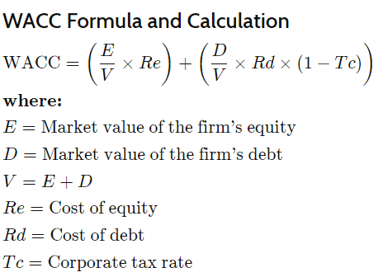

## Explaining the Formula Elements

[Cost of equity](https://www.investopedia.com/terms/c/costofequity.asp) (Re) can be a bit tricky to calculate because share capital does not technically have an explicit value. When companies reimburse bondholders, the amount they pay has a predetermined [interest rate](https://www.investopedia.com/terms/i/interestrate.asp). On the other hand, equity has no concrete price that the company must pay. As a result, companies have to estimate cost of equity—in other words, the rate of return that investors demand based on the expected [volatility](https://www.investopedia.com/terms/v/volatility.asp) of the stock.

Because shareholders will expect to receive a certain [return on their investments](https://www.investopedia.com/terms/r/returnoninvestment.asp) in a company, the equity holders’ required rate of return is a cost from the company’s perspective; if the company fails to deliver this expected return, shareholders will simply sell off their shares, which leads to a decrease in both share price and the company’s value. The cost of equity, then, is essentially the total return that a company must generate to maintain a share price that will satisfy its investors.

Companies typically use the [Capital Asset Pricing Model (CAPM)](https://www.investopedia.com/terms/c/capm.asp) to arrive at the cost of equity (in CAPM, it’s called the expected return of investment). Again, this is not an exact calculation because firms have to lean on historical data, which can never accurately predict future growth.2

Determining [cost of debt](https://www.investopedia.com/terms/c/costofdebt.asp) (Rd), on the other hand, is a more straightforward process. This is often done by averaging the yield to [maturity](https://www.investopedia.com/terms/m/maturity.asp) for a company’s outstanding debt. This method is easier if you’re looking at a publicly traded company that has to report its debt obligations.3

For privately owned companies, one can look at the company’s [credit rating](https://www.investopedia.com/terms/c/corporate-credit-rating.asp) from firms such as Moody’s and S&P and then add a relevant spread over risk-free assets (for example, Treasury notes of the same maturity) to approximate the return that investors would demand.

Businesses are able to deduct interest expenses from their taxes.4 Because of this, the net cost of a company’s debt is the amount of [interest](https://www.investopedia.com/terms/i/interest.asp) it is paying minus the amount it has saved in taxes. This is why Rd (1 - the corporate tax rate) is used to calculate the after-tax cost of debt.

## WACC vs. Required Rate of Return (RRR)

The required rate of return (RRR) is the minimum rate that an investor will accept for a project or investment. If they expect a smaller return than what they require, they’ll allocate their money elsewhere.

One way to determine the RRR is by using the CAPM, which uses a stock’s volatility relative to the broader market (its [beta](https://www.investopedia.com/terms/b/beta.asp)) to estimate the return that stockholders will require.

Another method for identifying the RRR is by calculating WACC. The advantage of using WACC is that it takes the company’s capital structure into account—that is, how much it leans on debt financing vs. equity.5

**What Is Economic Value Added (EVA)?**

Economic value added (EVA) is a measure of a company's [financial performance](https://www.investopedia.com/terms/f/financialperformance.asp) based on the residual wealth calculated by deducting its cost of capital from its operating profit, adjusted for taxes on a cash basis. EVA can also be referred to as [economic profit](https://www.investopedia.com/terms/e/economicprofit.asp), as it attempts to capture the true economic profit of a company. This measure was devised by management consulting firm Stern Value Management, originally incorporated as Stern Stewart & Co.1

KEY TAKEAWAYS

* Economic value added (EVA), also known as economic profit, aims to calculate the true economic profit of a company.
* EVA is used to measure the value a company generates from funds invested in it.
* However, EVA relies heavily on invested capital and is best used for asset-rich companies, where companies with intangible assets, such as technology businesses, may not be good candidates.

**Understanding Economic Value Added (EVA)**

EVA is the incremental difference in the [rate of return (RoR)](https://www.investopedia.com/terms/r/rateofreturn.asp) over a company's cost of capital. Essentially, it is used to measure the value a company generates from funds invested in it. If a company's EVA is negative, it means the company is not generating value from the funds invested into the business. Conversely, a positive EVA shows a company is producing value from the funds invested in it.

The formula for calculating EVA is:

EVA = NOPAT - (Invested Capital * WACC)

Where:

* [NOPAT](https://www.investopedia.com/terms/n/nopat.asp) = Net operating profit after taxes
* [Invested capital](https://www.investopedia.com/terms/i/invested-capital.asp) = Debt + capital leases + shareholders' equity
* [WACC](https://www.investopedia.com/terms/w/wacc.asp) = Weighted average cost of capital

The equation used for invested capital in EVA is usually total assets minus current liabilities—two figures easily found on a firm's balance sheet. In this case, the modified formula for EVA is NOPAT - (total assets - current liabilities) * WACC.

As noted by Stern Value Management, in 1983 the management team developed EVA, "a new model for maximizing the value created that can also be used to provide incentives at all levels of the firm."1 The goal of EVA is to quantify the cost of investing capital into a certain project or firm and then assess whether it generates enough cash to be considered a good investment. A positive EVA shows a project is generating returns in excess of the required minimum return.

EVA charges the company rent for tying up investors' cash to support operations. There is a hidden [opportunity cost](https://www.investopedia.com/terms/o/opportunitycost.asp) that goes to investors to compensate them for forfeiting the use of their own cash. EVA captures this hidden cost of capital that conventional measures ignore.

EVA is a performance metric that calculates the creation of [shareholder value](https://www.investopedia.com/terms/s/shareholder-value.asp); however, it distinguishes itself from traditional [financial performance](https://www.investopedia.com/terms/f/financialperformance.asp) metrics, such as [net profit](https://www.investopedia.com/ask/answers/122414/net-income-same-profit.asp) and [earnings per share](https://www.investopedia.com/terms/e/eps.asp) (EPS). EVA is the calculation of what profits remain after the [costs of a company's capital](https://www.investopedia.com/terms/c/costofcapital.asp)—debt and equity—are deducted from [operating profit](https://www.investopedia.com/terms/o/operating_profit.asp). The idea is simple but rigorous: true profit should account for the cost of capital.

To understand the difference between EVA and its infamous cousin, [net income](https://www.investopedia.com/terms/n/netincome.asp),

EVA as a performance indicator is very useful. The calculation shows how and where a company created wealth, through the inclusion of [balance sheet](https://www.investopedia.com/terms/b/balancesheet.asp) items. This forces managers to be aware of assets and expenses when making managerial decisions.

However, the EVA calculation relies heavily on the amount of [invested capital](https://www.investopedia.com/terms/i/invested-capital.asp) and is best used for asset-rich companies that are stable or mature. Companies with [intangible assets](https://www.investopedia.com/terms/i/intangibleasset.asp), such as technology businesses, may not be good candidates for an EVA evaluation.

EBIT (Earnings Before Interest and Taxes) is a measure of a company's operating income and represents the profit generated by a company's operations before taking into account the impact of interest and taxes. NOPAT (Net Operating Profit After Taxes) is a measure of a company's operating profitability that takes into account both the operating income and the tax expenses incurred by the company.

The main difference between using EBIT and EBT (Earnings Before Taxes) as inputs for calculating NOPAT is the treatment of interest expenses. EBT includes interest expenses as a deduction from operating income, while EBIT does not include interest expenses.

Using EBIT as the input for calculating NOPAT is preferred over using EBT because it provides a more accurate measure of a company's operating profitability. By excluding interest expenses, EBIT focuses solely on the profitability of a company's operations, without the influence of financial leverage.

In contrast, using EBT as the input for calculating NOPAT may overstate a company's operating profitability if it has a high level of debt. This is because interest expenses can be significant, especially for highly leveraged companies, and can artificially reduce EBT, leading to an overstated NOPAT.

Therefore, by using EBIT as the input for calculating NOPAT, analysts can better assess a company's underlying operating profitability, without the impact of financial leverage.

Total Operating Capital (TOC) is a financial metric that represents the total amount of capital invested in a company's operations. It is calculated by adding the company's total debt and equity (i.e., total capital) to the value of its net operating assets (NOA).

Net operating assets are a company's operating assets (e.g., inventory, accounts receivable, fixed assets) minus its operating liabilities (e.g., accounts payable, accrued expenses, deferred revenue). Essentially, NOA represents the amount of capital that a company needs to operate its business on a day-to-day basis.

The formula for calculating TOC is as follows:

TOC = Total Debt + Total Equity + Net Operating Assets

Or, alternatively:

TOC = Total Assets - Total Non-Operating Assets - Total Operating Liabilities

Total non-operating assets are assets that are not required for the day-to-day operations of the business, such as investments in other companies or real estate holdings. Total operating liabilities are liabilities that are related to the day-to-day operations of the business, such as accounts payable or accrued expenses.

TOC is an important metric because it represents the amount of capital that a company needs to generate in order to cover its operating expenses and continue operating in the long term. By tracking changes in TOC over time, investors and analysts can gain insights into a company's financial health, its ability to generate cash flows, and its overall operating efficiency.

¿Qué Incluye el TOC?

TOC = TOTAL OPERATING CAPITAL = CAPITAL OPERATIVO TOTAL

TOC = CAPITAL DE TRABAJO OPERATIVO + BIENES DE USO NETOS

CAPITAL DE TRABAJO OPERATIVO ==CAJA + CREDITOS + BIENES DE CAMBIO – DEUDA COMERIAL – PROVISIONES

(No confundir con Capital de Trabajo = Caja + Inversiones Corrientes + Créditos +bienes de cambio – deuda financiera de corto plazo – deuda comercial –provisiones)

BIENES DE USO NETOS= BIENES DE USO VALOR ORIGINAL – AMORTIZACIONES ACUMULADAS

Sure, here's a list of commonly used financial ratios with their description and formulas:

1. Liquidity ratios:

a. Current Ratio: This ratio measures a company's ability to pay its short-term obligations with its current assets.

Current Ratio = Current Assets / Current Liabilities

b. Quick Ratio: This ratio measures a company's ability to pay its short-term obligations with its most liquid assets.

Quick Ratio = (Current Assets - Inventory) / Current Liabilities

1. Debt ratios:

a. Debt-to-Equity Ratio: This ratio measures a company's leverage by comparing its total liabilities to its total equity.

Debt-to-Equity Ratio = Total Liabilities / Total Equity

b. Interest Coverage Ratio: This ratio measures a company's ability to meet its interest payments by comparing its earnings before interest and taxes (EBIT) to its interest expense.

Interest Coverage Ratio = EBIT / Interest Expense

1. Asset Management Ratios:

a. Inventory Turnover Ratio: This ratio measures how efficiently a company is managing its inventory by comparing its cost of goods sold to its average inventory.

Inventory Turnover Ratio = Cost of Goods Sold / Average Inventory

b. Asset Turnover Ratio: This ratio measures how efficiently a company is using its assets to generate revenue.

Asset Turnover Ratio = Revenue / Total Assets

1. Profitability Ratios:

a. Gross Profit Margin Ratio: This ratio measures a company's profitability by comparing its gross profit to its revenue.

Gross Profit Margin Ratio = (Revenue - Cost of Goods Sold) / Revenue

b. Net Profit Margin Ratio: This ratio measures a company's profitability by comparing its net profit to its revenue.

Net Profit Margin Ratio = Net Profit / Revenue

1. Market Value Ratios:

a. Price-to-Earnings Ratio (P/E Ratio): This ratio measures a company's stock price relative to its earnings per share (EPS).

P/E Ratio = Market Price per Share / Earnings per Share

b. Market-to-Book Ratio: This ratio measures a company's stock price relative to its book value per share.

Market-to-Book Ratio = Market Price per Share / Book Value per Share

These ratios can provide valuable insights into a company's financial health, operating efficiency, and overall profitability. However, it's important to interpret them in conjunction with other financial ratios and qualitative factors to fully understand a company's financial performance.

**What Is the DuPont Analysis?**

The DuPont analysis is a framework for analyzing fundamental performance popularized by the DuPont Corporation. DuPont analysis is [a useful technique](https://www.investopedia.com/articles/fundamental-analysis/08/dupont-analysis.asp) used to decompose the different drivers of [return on equity (ROE)](https://www.investopedia.com/terms/r/returnonequity.asp). The decomposition of ROE allows [investors](https://www.investopedia.com/terms/i/investor.asp) to focus on the key metrics of financial performance individually to identify strengths and weaknesses. There are two versions of the tool—one which accounts for decomposition in three steps while the other does so in five steps.

KEY TAKEAWAYS

* The DuPont analysis is a framework for analyzing fundamental performance originally popularized by the DuPont Corporation.
* The formula was developed in 1914 by F. Donaldson Brown, an employee of the DuPont Corporation.
* DuPont analysis is a useful technique used to decompose the different drivers of return on equity.
* An investor can use analysis tools like this to compare the operational efficiency of two similar firms.
* Managers can use DuPont analysis to identify strengths or weaknesses that should be addressed.

There are three major financial metrics that drive ROE:

* [operating efficiency](https://www.investopedia.com/terms/o/operationalefficiency.asp), which is represented by [net profit margin](https://www.investopedia.com/terms/n/net_margin.asp) or net income divided by total sales or revenue
* asset use efficiency, which is measured by the [asset turnover ratio](https://www.investopedia.com/terms/a/assetturnover.asp)
* financial [leverage](https://www.investopedia.com/terms/l/leverage.asp)—a metric that is measured by the equity multiplier, which is equal to average assets divided by average equity

The DuPont model breaks ROE into three components:

1. Profit Margin: This component measures a company's ability to generate profit from its sales.

Profit Margin = Net Income / Sales

1. Asset Turnover: This component measures how efficiently a company uses its assets to generate sales.

Asset Turnover = Sales / Total Assets

1. Financial Leverage: This component measures how much a company relies on debt to finance its operations.

Financial Leverage = Total Assets / Total Equity

The DuPont model combines these three components into a single equation:

ROE = Profit Margin x Asset Turnover x Financial Leverage

### Net Profit Margin

The net profit margin is the ratio of bottom line profits compared to total revenue or total sales. This is one of the most basic measures of profitability.

The profit margin can be improved if costs for the owner were reduced or if prices were raised, which can have a large impact on ROE. This is one of the reasons that a company's stock will experience high levels of [volatility](https://www.investopedia.com/terms/v/volatility.asp) when management makes a change to its [guidance](https://www.investopedia.com/terms/g/guidance.asp) for future margins, costs, and prices.

### Asset Turnover Ratio

A normal asset turnover ratio will vary from one industry group to another. For example, a discount retailer or grocery store will generate a lot of revenue from its assets with a small [margin](https://www.investopedia.com/terms/m/margin.asp), which will make the asset turnover ratio very large. On the other hand, a utility company owns very expensive [fixed assets](https://www.investopedia.com/terms/f/fixedasset.asp) relative to its revenue, which will result in an asset turnover ratio that is much lower than that of a retail firm.3

The ratio can be helpful when comparing two companies that are very similar. Because average assets include components like inventory, changes in this ratio can signal that sales are slowing down or speeding up earlier than they would show up in other financial measures. If a company's asset turnover rises, its ROE improves.

### Financial Leverage

Financial leverage, or the equity multiplier, is an indirect analysis of a company's use of debt to finance its assets.

Most companies should use debt with equity to fund operations and growth. Not using any leverage could put the company at a disadvantage compared with its peers. However, using too much [debt](https://www.investopedia.com/terms/d/debt.asp) in order to increase the financial leverage ratio—and therefore increase ROE—can create disproportionate risks.

A point to note, though, is that some companies use balance sheet averages when one of the components is an income statement metric. In the case noted above, no averaging is necessary as the equation takes balance sheet/balance sheet figures into account.



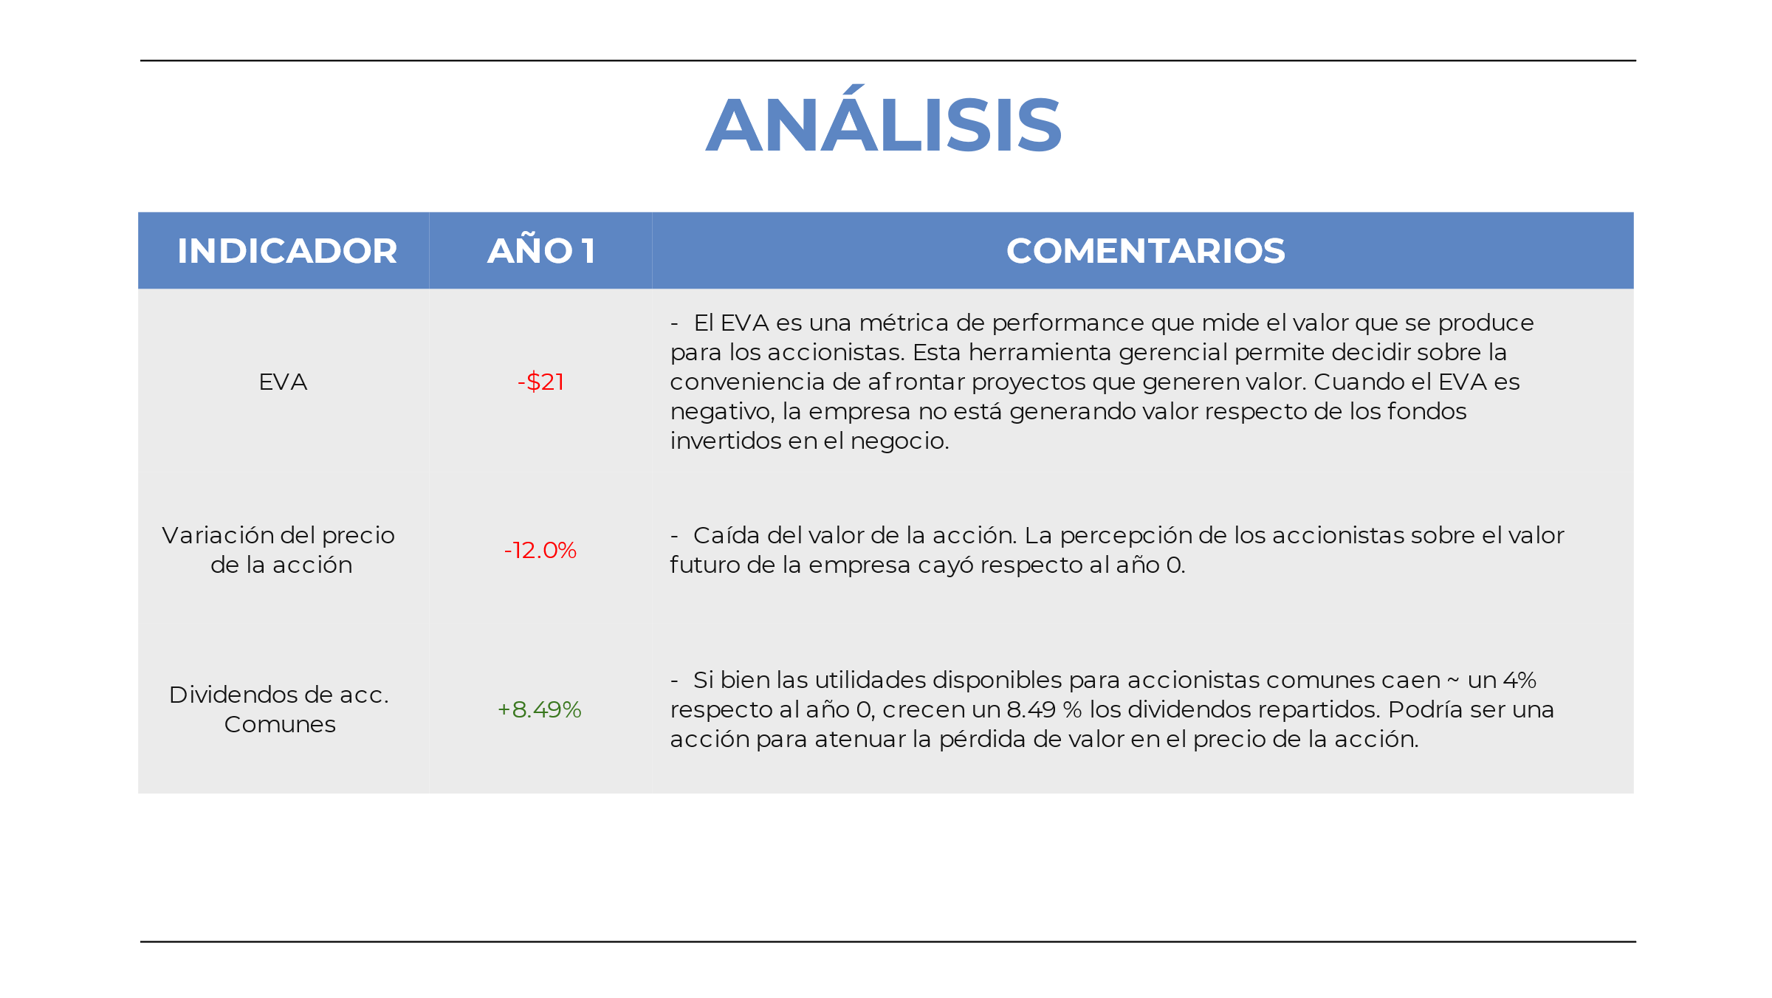

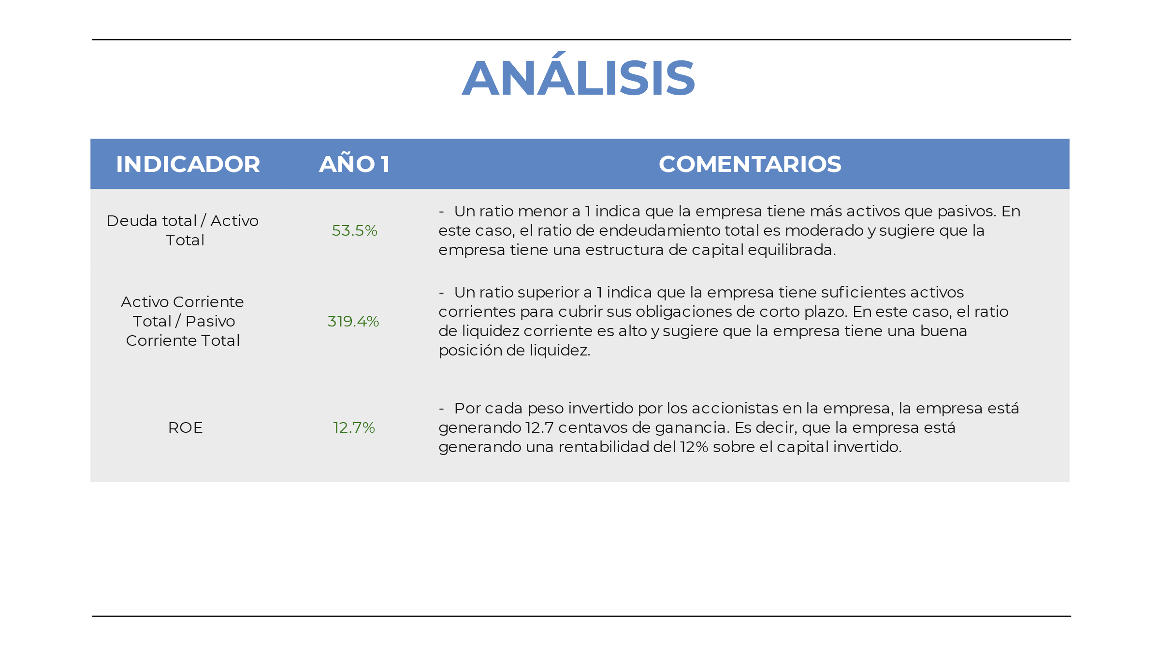

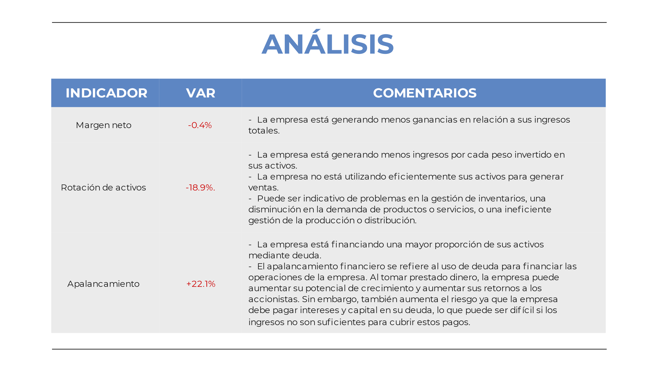

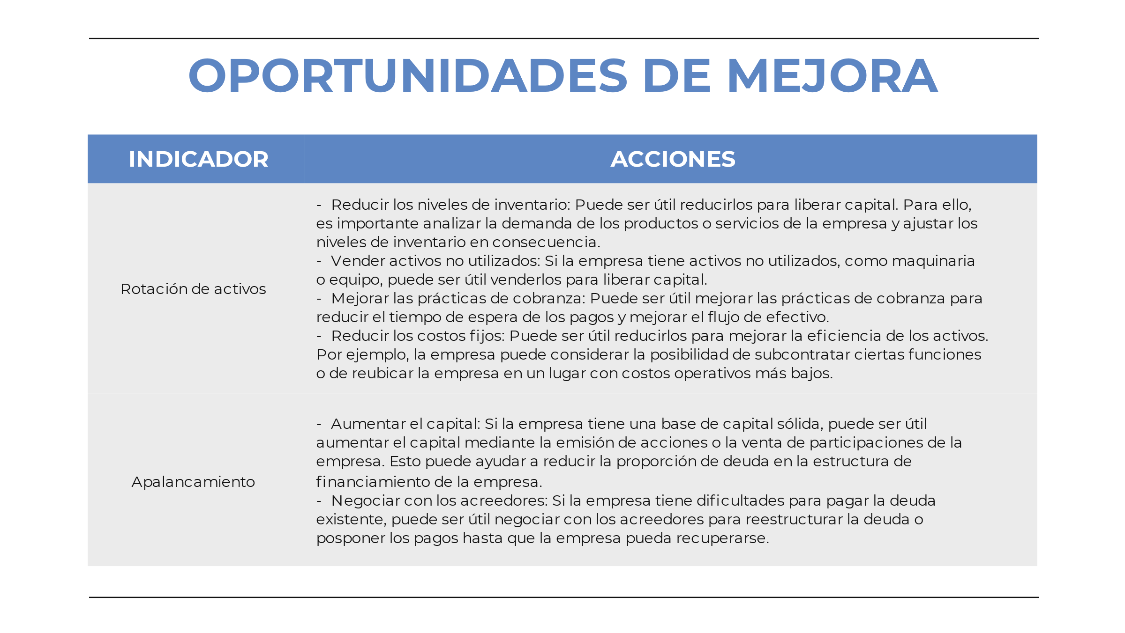

Simple interest is a method of calculating interest on a loan or investment that is based only on the principal amount. It is calculated as a percentage of the principal amount, multiplied by the number of years for which the interest is being calculated. The interest earned or charged in each period remains constant, and there is no compounding of interest over time.

The formula for calculating simple interest is:

Simple Interest = Principal x Rate x Time

where:

* Principal is the initial amount of money
* Rate is the annual interest rate as a decimal
* Time is the number of years

For example, if you borrow $1,000 at an annual interest rate of 5% for 3 years, the simple interest calculation would be:

Simple Interest = $1,000 x 0.05 x 3 = $150

So, the total amount repaid at the end of the 3-year period would be $1,150 ($1,000 + $150).

Compound interest, on the other hand, is a method of calculating interest on a loan or investment that includes not only the principal amount but also the interest earned or charged over time. In other words, the interest is compounded, or added to the principal, at regular intervals.

The formula for calculating compound interest is:

Compound Interest = P(1 + r/n)^(nt) - P

where:

* P is the principal amount
* r is the annual interest rate as a decimal
* n is the number of times the interest is compounded per year
* t is the number of years

For example, if you invest $1,000 at an annual interest rate of 5% compounded monthly for 3 years, the compound interest calculation would be:

Compound Interest = $1,000(1 + 0.05/12)^(12x3) - $1,000 = $158.38

So, the total amount earned at the end of the 3-year period would be $1,158.38 ($1,000 + $158.38).

The compounding period refers to the frequency at which interest is compounded on a loan or investment. The more frequent the compounding, the higher the effective interest rate and the more interest earned or charged over time.

For example, consider a loan of $10,000 at an annual interest rate of 6%, with different compounding periods:

* Annual compounding: The interest is compounded once a year, resulting in an effective interest rate of 6%. After one year, the loan balance would be $10,600 ($10,000 + $600 in interest).
* Semi-annual compounding: The interest is compounded twice a year, resulting in an effective interest rate of 6.09%. After one year, the loan balance would be $10,609 ($10,000 + $609 in interest).
* Quarterly compounding: The interest is compounded four times a year, resulting in an effective interest rate of 6.14%. After one year, the loan balance would be $10,614 ($10,000 + $614 in interest).
* Monthly compounding: The interest is compounded twelve times a year, resulting in an effective interest rate of 6.17%. After one year, the loan balance would be $10,617 ($10,000 + $617 in interest).

As you can see from the above example, the more frequent the compounding period, the higher the effective interest rate and the more interest earned or charged over time.

| **Compounding Frequency** | **Effective Interest Rate** | **Loan Balance After One Year** |
| --- | --- | --- |
| Annual | 6.00% | $10,600 |
| Semi-Annual | 6.09% | $10,609 |
| Quarterly | 6.14% | $10,614 |
| Monthly | 6.17% | $10,617 |

1. Annual compounding: The interest is added to the principal once a year. The frequency of capitalization is 1.
2. Semi-annual compounding: The interest is added to the principal twice a year. The frequency of capitalization is 2.
3. Quarterly compounding: The interest is added to the principal four times a year. The frequency of capitalization is 4.
4. Monthly compounding: The interest is added to the principal twelve times a year. The frequency of capitalization is 12.
5. Daily compounding: The interest is added to the principal every day. The frequency of capitalization is 365 (or 366 in a leap year).
6. Continuous compounding: The interest is added to the principal continuously. The frequency of capitalization is infinite.

# **APR vs. APY: What’s the Difference?**

APR and APY may sound the same, but they are not created equal

### KEY TAKEAWAYS

* APR represents the annual rate charged for earning or borrowing money.
* APY takes into account compounding, but APR does not.
* The more frequently the interest compounds, the greater the difference between APR and APY.
* Investment companies generally advertise the APY, while lenders tout APR.

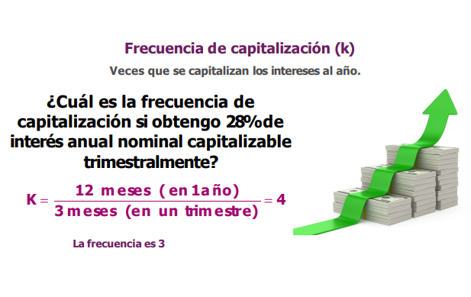

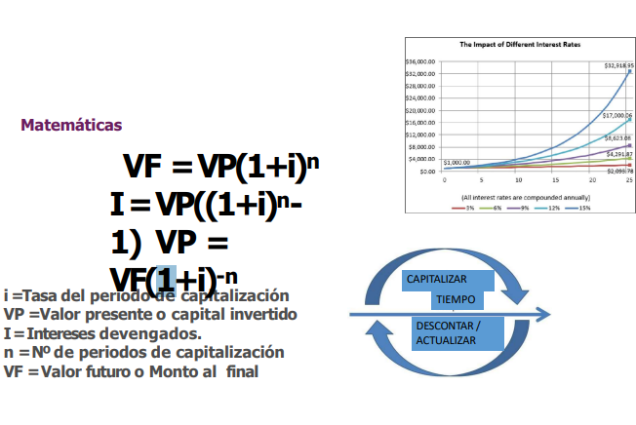

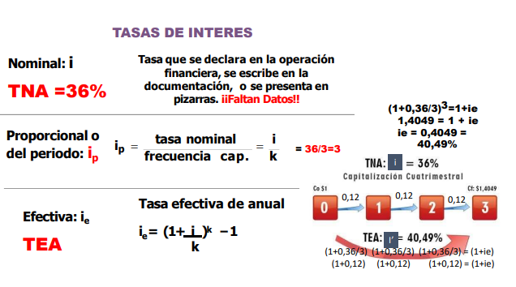

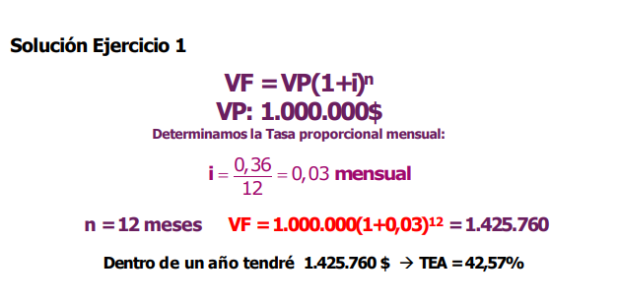

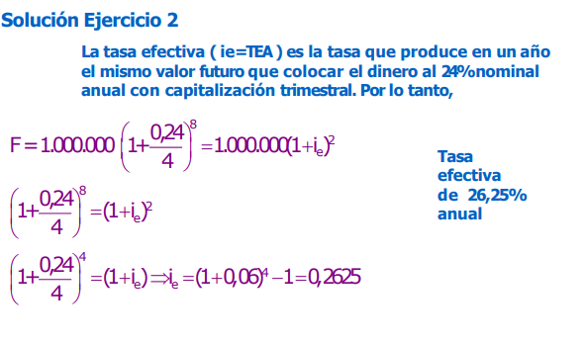

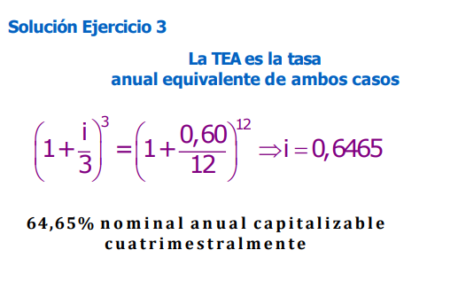

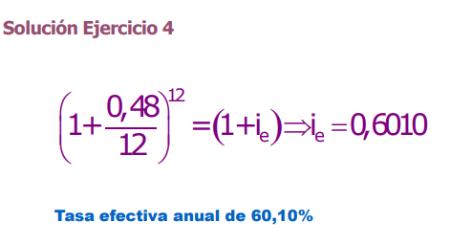

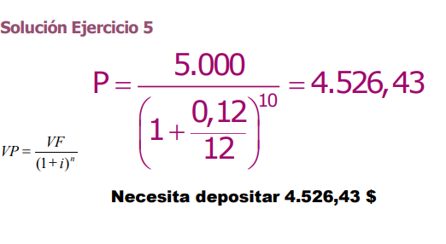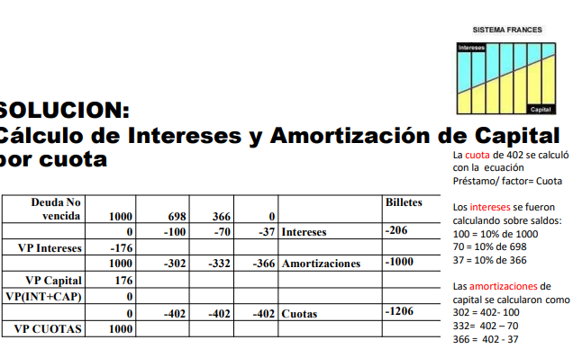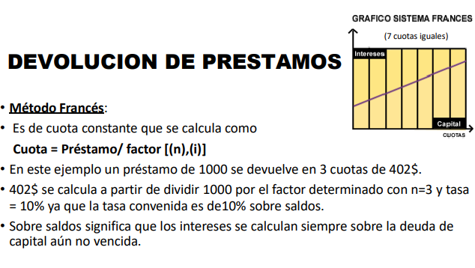

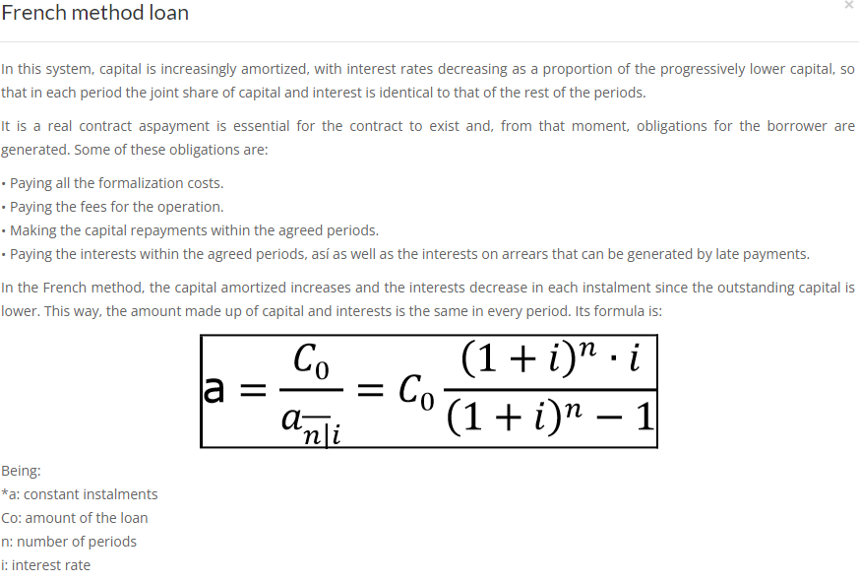

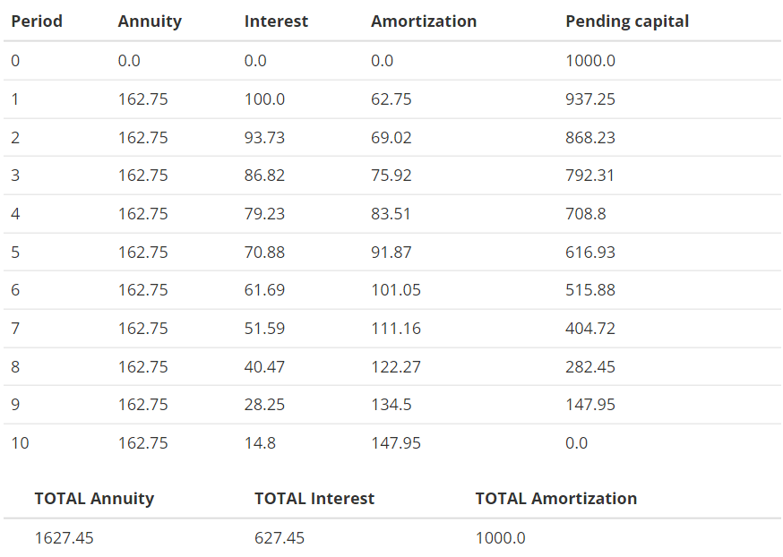



### Parte 1 - Métodos de devolución de préstamos

#### Método Alemán

Al igual que como sucede en el método francés, la cuota que se abona periódicamente tiene dos componentes: una parte destinada a la amortización del capital y otra en concepto de interés. En ambos sistemas el cálculo de la parte correspondiente al interés es el mismo, ya que se calcula sobre saldos, es decir, sobre la deuda de capital aún no vencida. El cálculo de la amortización, en cambio, se efectúa de manera diferente. En el sistema alemán, la parte destinada a amortizar capital es igual en todas las cuotas, mientras que los intereses son decrecientes, lo que determina que la cuota total sea decreciente.

**Composición de las cuotas** = Amortización de capital + Interés

**Amortización de Capital** = monto original prestado / cantidad de cuotas

**Interés** = tasa pactada x saldo al final del período anterior

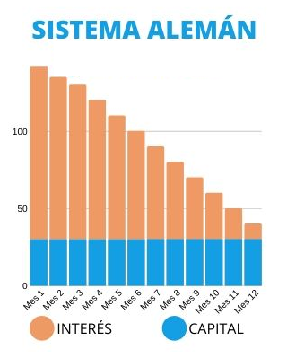

#### Método Americano o Bullet

En este método se determina que el deudor pagará una **anualidad** que es constante e incluye únicamente los intereses. El capital prestado se devolverá en un solo pago sumado a la última cuota. Por su mecánica de amortización, este sistema es el que más intereses paga, ya que no cuenta con devoluciones parciales del capital y las anualidades consideran siempre el monto total prestado al inicio.

**Composición de las cuotas**:

Desde 1 hasta n -1 = Interés

Cuota Final = Capital (total) + Interés

**Amortización de Capital** = Total en la última cuota

**Interés** = tasa pactada x capital total prestado

Una modalidad de este sistema es el *Sinking Fund*, que consiste en crear un fondo asociado al préstamo para construir un capital con el que se cancelará la cuota final del préstamo (capital + intereses).

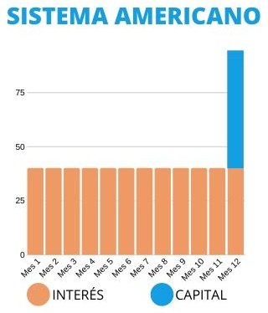

#### Método de Interés Directo

En este sistema se calculan los intereses simples sobre el total de la deuda y el importe de las cuotas se obtiene dividiendo el monto resultante por el número de cuotas. Esta metodología determina un interés a pagar mayor que en los sistemas francés y alemán dado que éste no se calcula sobre los saldos, sino sobre el total del préstamo.

**Composición de las cuotas**: Total a pagar / cantidad de cuotas

Deuda: Vn; Tasa directa (mensual): Tid; Plazo del préstamo (meses): n

**Interés Total** = tasa pactada x capital total prestado = Vn x Tid x n

**Total a pagar** = Vn + Vn x Tid x n = Vn x (1 + Tid x n)

**Cuota =** Total a pagar / n = Vn x (1/n + Tid)

**Resolución del ejercicio planteado en la hoja “Cuotas y Componentes” del “Entregable 2”.**



If the horizon of analysis is limited to 5 periods, the dividend model for stock price valuation would consider the dividends paid during those 5 periods as well as the future dividends that the company is expected to pay during those 5 periods.

The formula for the dividend model would be:

PV = (D1/(1+r)^1) + (D2/(1+r)^2) + (D3/(1+r)^3) + (D4/(1+r)^4) + (D5/(1+r)^5)

Where: PV = present value of the stock D1, D2, D3, D4, D5 = dividends expected to be paid during the 5 periods r = required rate of return

In contrast, if the horizon of analysis is not limited and the company is expected to pay dividends indefinitely, the formula for the dividend model would be:

PV = (D1/(1+r)^1) + (D2/(1+r)^2) + (D3/(1+r)^3) + ... + (Dn/(1+r)^n)

Where: PV = present value of the stock D1, D2, D3, ... Dn = dividends expected to be paid indefinitely r = required rate of return

In this case, the formula includes an infinite number of terms, which requires the use of a perpetuity formula to calculate the present value.

The dividend model is a stock valuation approach that estimates the intrinsic value of a stock based on its expected future dividends. The basic premise of the dividend model is that the value of a stock is the present value of its expected future dividend payments, discounted at an appropriate rate.

There are two versions of the dividend model: the dividend discount model (DDM) and the dividend capitalization model (DCM). The DDM assumes that dividends are paid at a constant rate, while the DCM assumes that dividends grow at a constant rate.

The formula for the dividend discount model is as follows:

P = D / (r - g)

Where: P = the price of the stock D = the expected dividend payment r = the required rate of return g = the expected dividend growth rate

The formula for the dividend capitalization model is as follows:

P = (D0 * (1 + g)) / (r - g)

Where: P = the price of the stock D0 = the current dividend payment r = the required rate of return g = the expected dividend growth rate

In both formulas, the required rate of return represents the minimum return an investor expects to earn on their investment, while the expected dividend growth rate represents the rate at which the company is expected to increase its dividend payments over time. The assumption in the DCM is that the dividend growth rate is constant over time, while the DDM assumes that the dividend payment is constant.

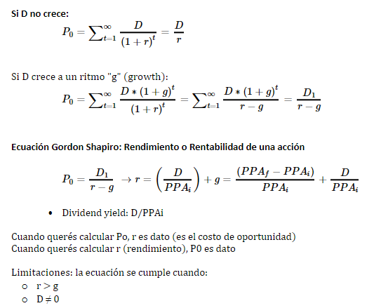

P0 = D1 / (r-g)

P0 * (r-g) = D1

(r-g) = D1/P0

r = D1/P0 + g

D1/P0 capital gain

g dividend gain





Si descuenta los 5 primeros periodos, se obtiene un precio de $4,98.

Debería descontar un número mayor de flujos de dividendos para acercarse

asintóticamente al precio descontado en infinitos periodos.

En caso de solo descontar un número bajo y finito de dividendos, está asumiendo

que no se pagarán dividendos pasado ese periodo. En ese caso, el modelo falla

en valuar el precio, dado que asume que la empresa siempre paga dividendos.



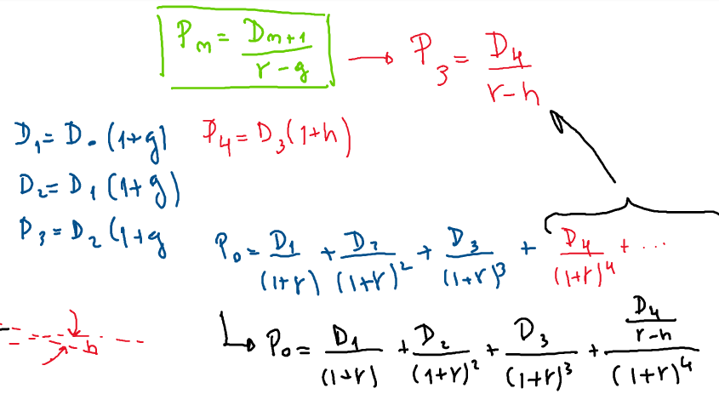

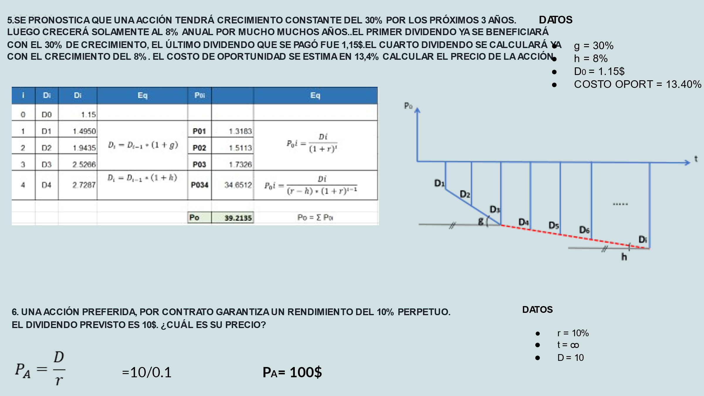





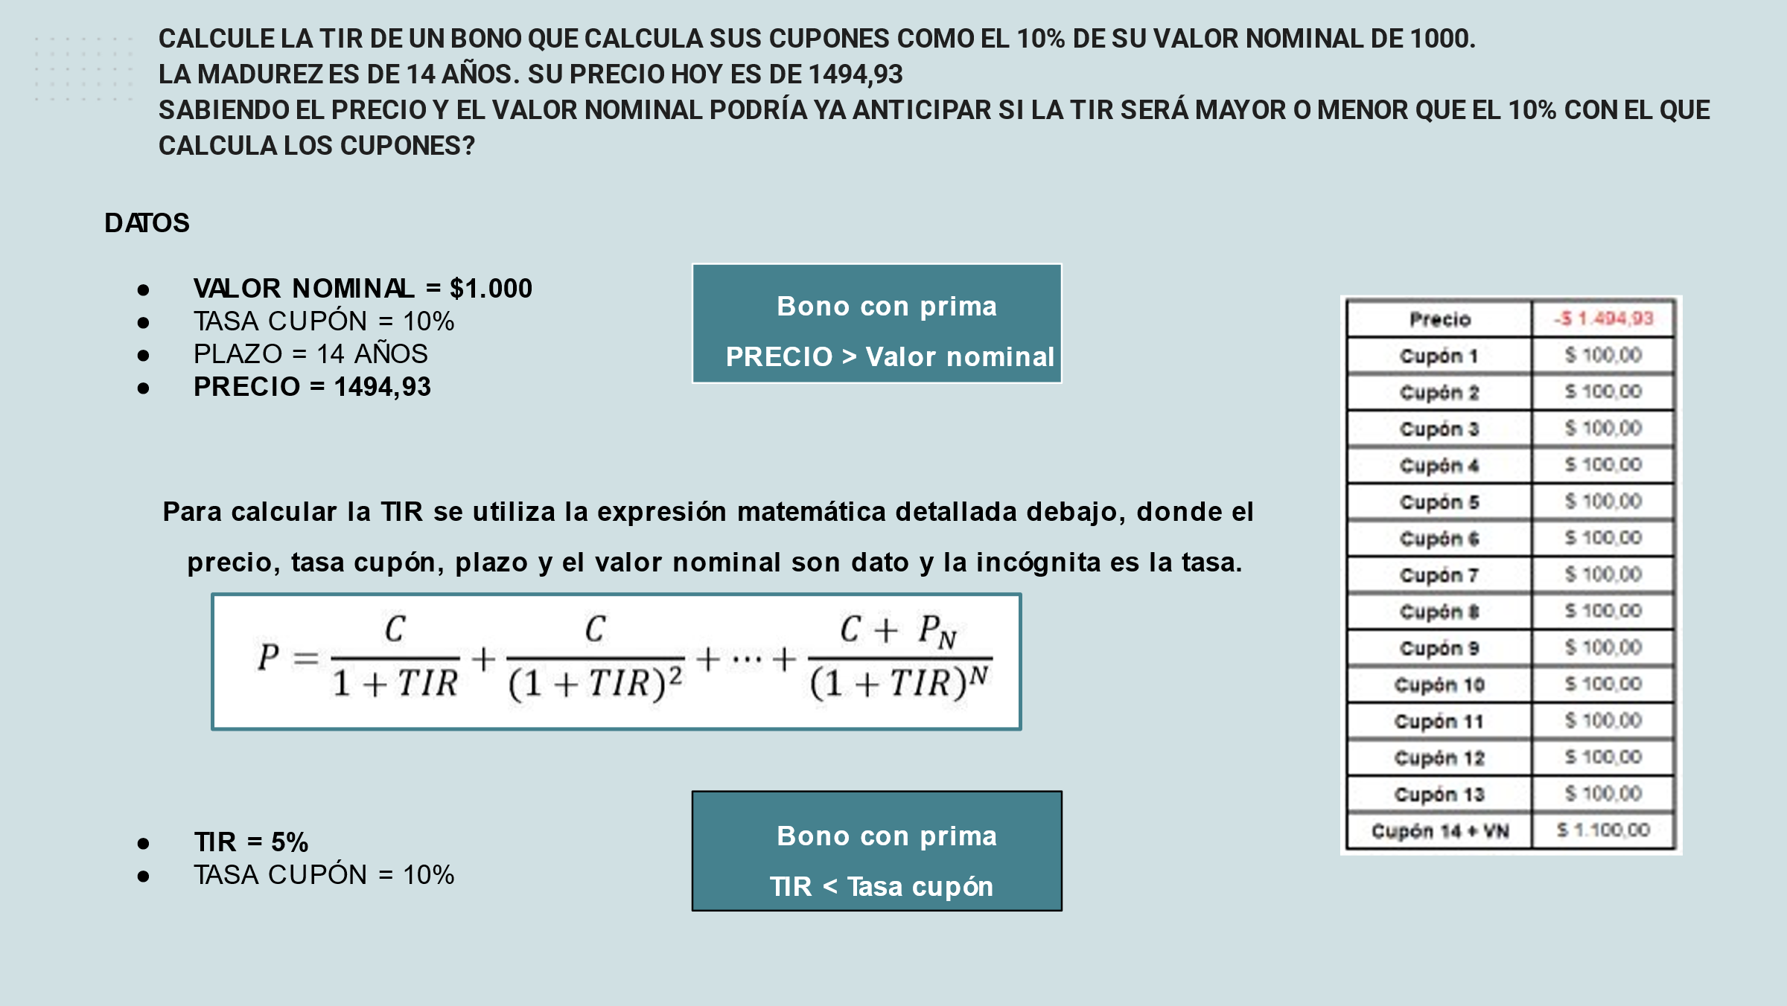

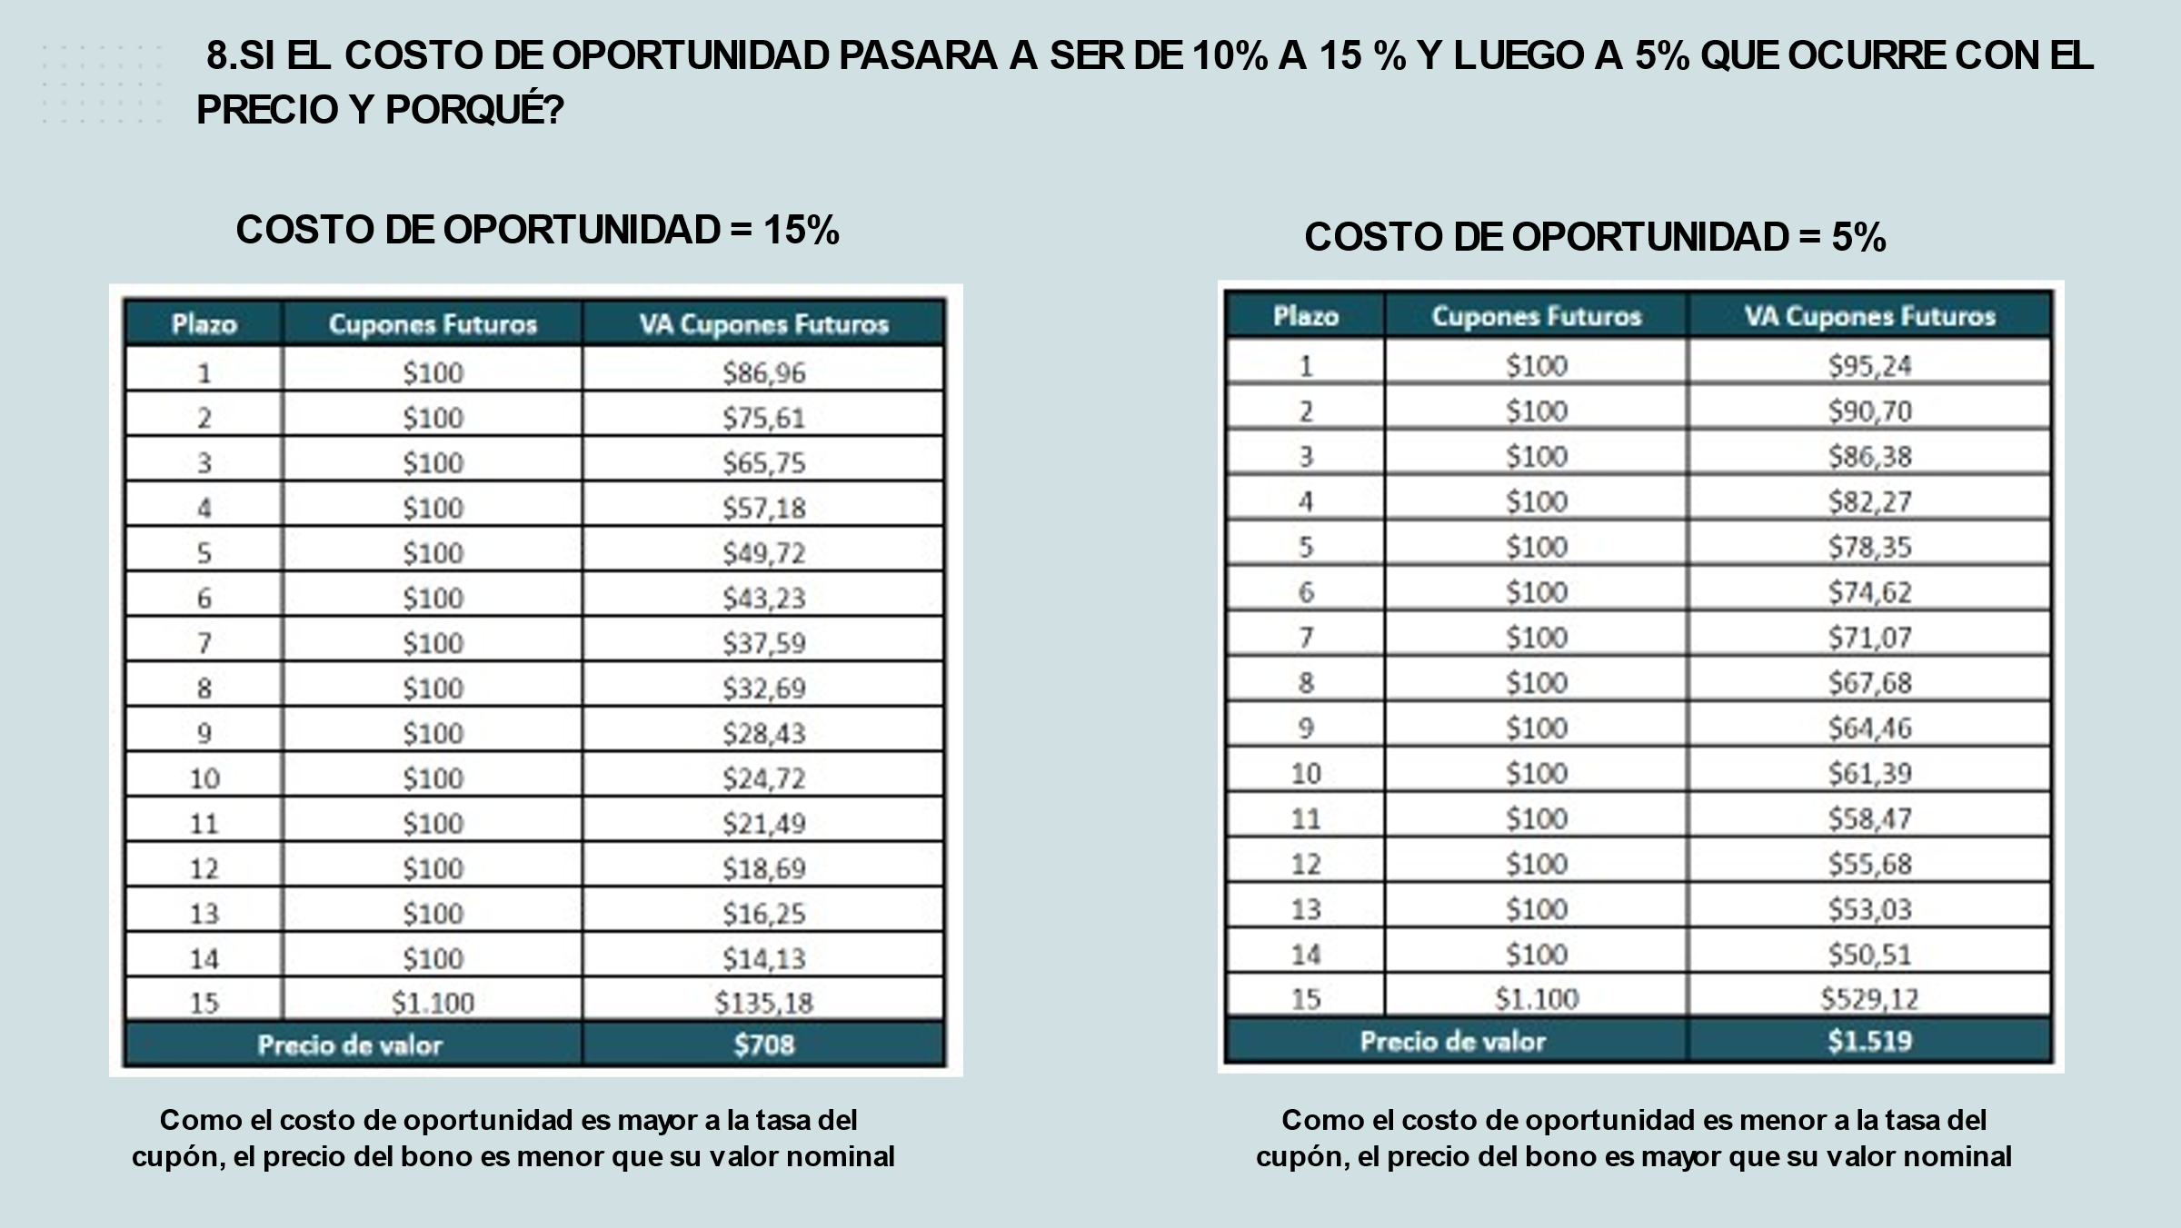



La TIR (tasa interna de retorno) de un bono es la tasa de descuento que hace que el valor presente de los flujos de efectivo futuros del bono sea igual a su precio actual. En otras palabras, es la tasa de rendimiento efectiva que un inversor obtendría si comprara el bono y lo mantuviera hasta su vencimiento, asumiendo que los flujos de efectivo futuros del bono se reinvierten a la misma tasa.

Si la TIR es menor que la tasa de cupón del bono, esto significa que el bono se está vendiendo a un precio mayor que su valor presente. Precio = VN entonces TIR = CUPON.

En este escenario, el inversionista podría considerar que el bono está sobrevalorado y buscar alternativas de inversión más atractivas. Si pagas un precio bajo, mayor TIR.

La TIR nos dice la rentabilidad media anual que obtendríamos por el bono comprado al precio que está en ese momento si lo mantenemos hasta el vencimiento. Es decir, la TIR incluye los beneficios de la rentabilidad del cupón y la rentabilidad al amortizar el bono.

Por tanto, interpretación: La Deuda pública española. Nos paga de cupón un 6% anual y tiene una TIR del 1,83% ¿ A quién le hacemos caso? A la TIR. La rentabilidad media que cobraremos por la deuda pública es un 1,83%. Es cierto que cobraremos de cupón anual un 6%, pero porque la estamos comprando muy cara. El precio ha subido desde que se emitió.

Yield to maturity es la TIR.

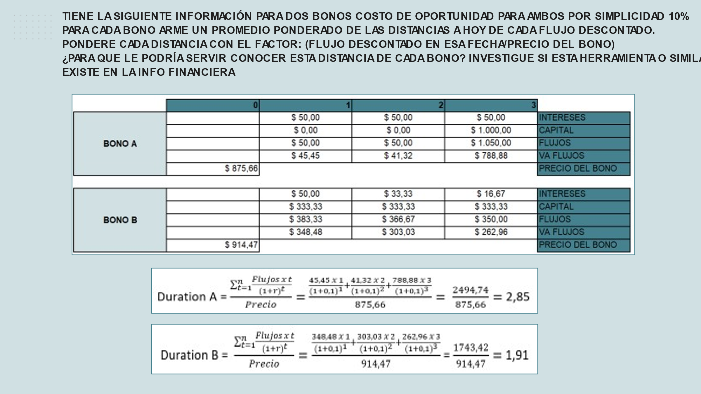



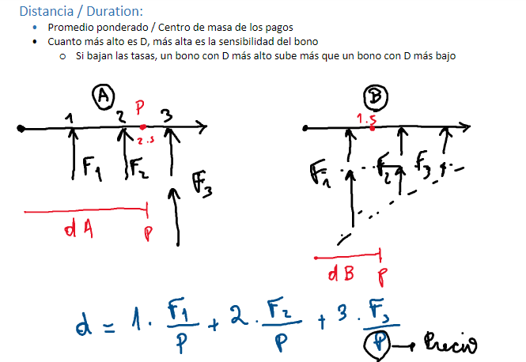

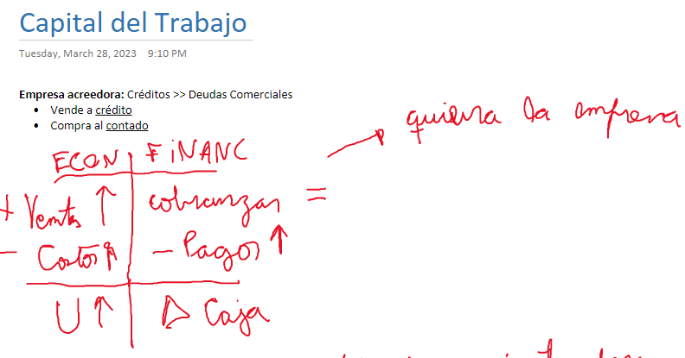

**PLANEAMIENTO FINANCIERO - PLANEAMIENTO DE CAJA**

**Escenario de una empresa:**

* Activo > pasivo corriente.
* Compra al contado (mayor parte).
* Vende a crédito.
* Utilidades buenas.
* Ventas - Créditos = Utilidades (económica).

**Pero si observo los plazos en los que cobro, y en los que pago, entra en juego la parte financiera:**

* Cobranzas - Pagos = Var. Caja (Hay que ver la variación caja durante un periodo).
* Pueden mejorar las ventas, mejorando utilidades, pero el flujo de dinero no se cobra enseguida (hay descalce plazo, entre pagos a proveedores, deudas y cobranzas a clientes).

**¿Qué pasa si los pagos que haces son mayores a las cobranzas?**

La situación descrita indica que la empresa está enfrentando una restricción de efectivo debido a que los pagos son mayores a las cobranzas. A pesar de que la empresa tiene un activo mayor que su pasivo corriente, no tener suficiente efectivo para hacer frente a sus obligaciones corrientes podría ser un problema.

Es importante que la empresa analice su flujo de efectivo para identificar las causas de la restricción. Es posible que la empresa necesite ajustar su política de crédito y cobranza para asegurarse de que los clientes paguen a tiempo. También podría ser necesario buscar nuevas fuentes de financiamiento a corto plazo, como una línea de crédito renovable o un descuento en facturas.

Además, la empresa debe revisar su proceso de compras para asegurarse de que está obteniendo los mejores precios y evitando compras innecesarias. También es importante controlar los costos operativos y buscar formas de reducirlos si es posible.

En resumen, la empresa debe enfocarse en mejorar su gestión de efectivo y su flujo de efectivo para evitar problemas financieros a corto plazo y mejorar su rentabilidad a largo plazo.

*Desde <*[*https://chat.openai.com/chat/a872eab7-c330-4b1e-9dfd-efbdeb6b655c*](https://chat.openai.com/chat/a872eab7-c330-4b1e-9dfd-efbdeb6b655c)*>*

1. **Acreedora ante expansión:**

Si una empresa es "acreedora ante expansión" significa que tiene la capacidad financiera para financiar su crecimiento o expansión mediante sus propios recursos sin tener que recurrir a financiamiento externo, es decir, tiene suficiente liquidez y capital para invertir en nuevos proyectos o en la expansión de su negocio.

En otras palabras, la empresa tiene más activos que pasivos y por lo tanto, cuenta con una estructura financiera sólida que le permite afrontar sus necesidades de crecimiento sin tener que asumir deudas o compromisos financieros significativos que puedan poner en riesgo su estabilidad financiera a largo plazo.

EXPLAIN ECONOMIC AND FINANCIAL SITUATION OF A COMPANY WITH PROFITS > 0, HIGH AMORTIZATION COSTS AND COLLECTIONS > PAYMENTS

A company with profits greater than zero, high amortization costs, and collections greater than payments may be in a relatively healthy economic and financial situation.

The fact that the company has positive profits means that it is generating revenue and that its expenses are being managed effectively. The high amortization costs could indicate that the company is investing in long-term assets, such as property, plant, and equipment, which can help to increase its efficiency and productivity in the long run.

Additionally, the fact that the company is collecting more than it is paying out could indicate that it has a strong cash flow, which can help it to cover its expenses and continue to invest in growth opportunities. This could be a positive sign for investors and stakeholders.

Overall, while high amortization costs could impact short-term profitability, if the company is effectively managing its cash flow and investing in long-term assets, it may be in a strong position for future growth and success.

La gestión del activo corriente se refiere a la administración eficiente de los recursos financieros de corto plazo que una empresa utiliza en sus operaciones diarias, incluyendo el efectivo, los inventarios y las cuentas por cobrar. El objetivo de la gestión del activo corriente es mantener un equilibrio adecuado entre el nivel de inversión en estos activos y la capacidad de la empresa para convertirlos en efectivo en el momento adecuado, para así cumplir con sus obligaciones y generar ganancias.

Para financiar el activo corriente, una empresa puede utilizar una combinación de fuentes de financiamiento a corto y largo plazo. El pasivo corriente, como los préstamos bancarios y las cuentas por pagar, puede proporcionar financiamiento a corto plazo, mientras que el financiamiento a largo plazo, como los préstamos a largo plazo o la emisión de bonos, puede proporcionar recursos adicionales para financiar el activo corriente y otros activos a largo plazo.

La combinación de financiamiento a corto y largo plazo depende de la política financiera de la empresa, sus necesidades de financiamiento y la estructura de su balance general. La gestión efectiva del activo corriente y su financiamiento correspondiente son esenciales para garantizar la solidez financiera y el crecimiento de una empresa a largo plazo.

En general, el financiamiento a través del patrimonio (acciones) es menos costoso para la empresa que el financiamiento a través de pasivos (deuda). Esto se debe a que los accionistas no exigen pagos fijos de intereses o principal como los prestamistas, y están dispuestos a asumir un mayor riesgo debido a que su inversión está en última instancia respaldada por los activos y el flujo de efectivo de la empresa.

Sin embargo, el financiamiento con patrimonio también puede ser más riesgoso para la empresa, ya que los accionistas tienen derechos sobre las ganancias y pueden ejercer su poder en la toma de decisiones empresariales. Si la empresa tiene una rentabilidad inconsistente, los accionistas pueden perder la confianza en la empresa y vender sus acciones, lo que puede disminuir el valor de las acciones y afectar negativamente el costo de capital de la empresa.

Por otro lado, el financiamiento a través de pasivos (deuda) puede ser menos riesgoso en términos de la gestión de la empresa, ya que los prestamistas no tienen derecho a participar en las decisiones empresariales. Además, la deuda tiene un costo fijo de intereses, lo que permite a la empresa planificar y presupuestar de manera más predecible. Sin embargo, la deuda puede ser más costosa para la empresa en términos de los pagos de intereses y principal, y puede aumentar el riesgo de incumplimiento en caso de una disminución en el flujo de efectivo de la empresa.

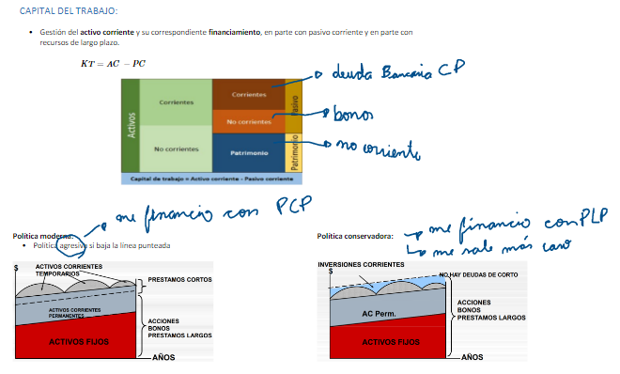

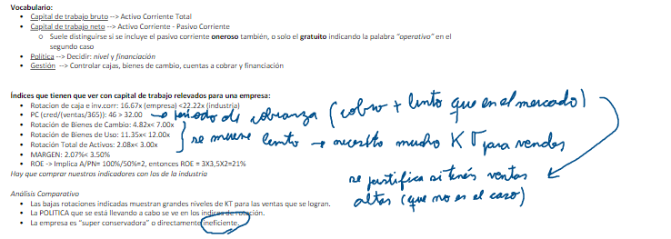

¿Es ineficiente o conservadora?

ο Si fuera un tema de ser conservadora (relajada en la inversión en KT pensando que eso le facilita mucho vender y lograr grandes resultados) se vería en la rentabilidad que estaría logrando.

ο Pero... tampoco se ven esos resultados en rentabilidad...

ο Parece que la empresa tiene excesos de KT

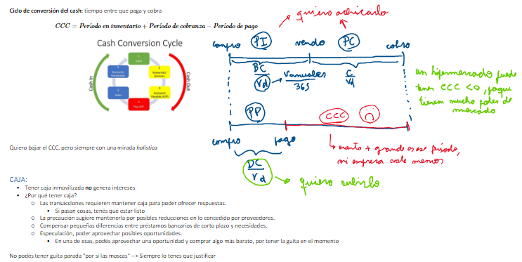

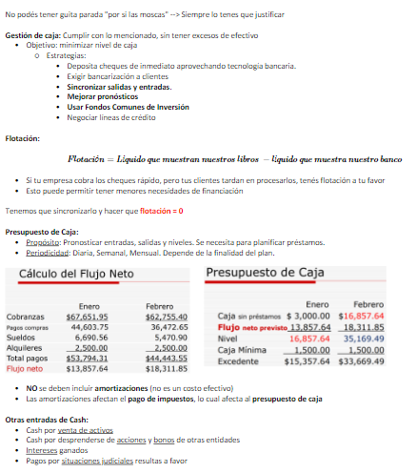

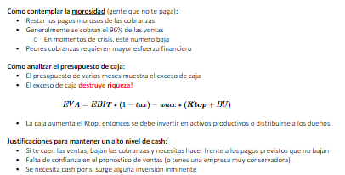

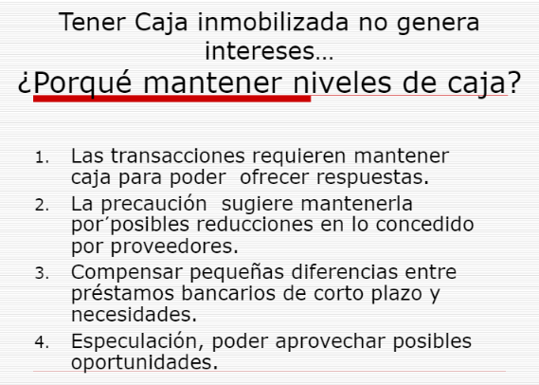

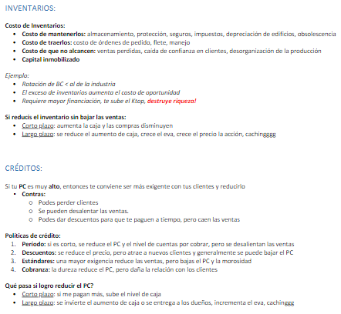

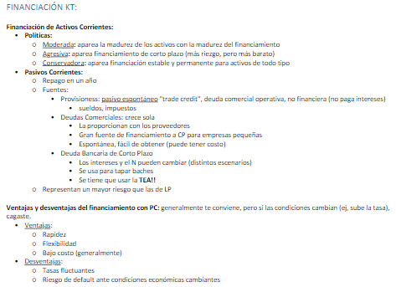

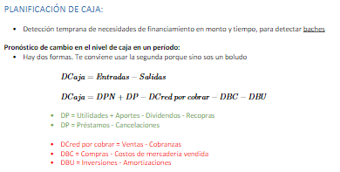

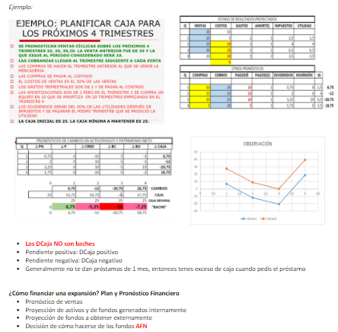

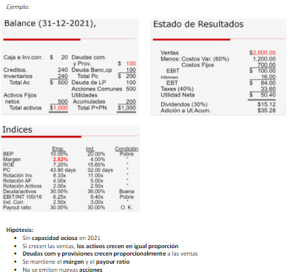

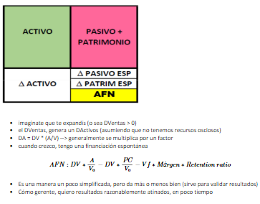

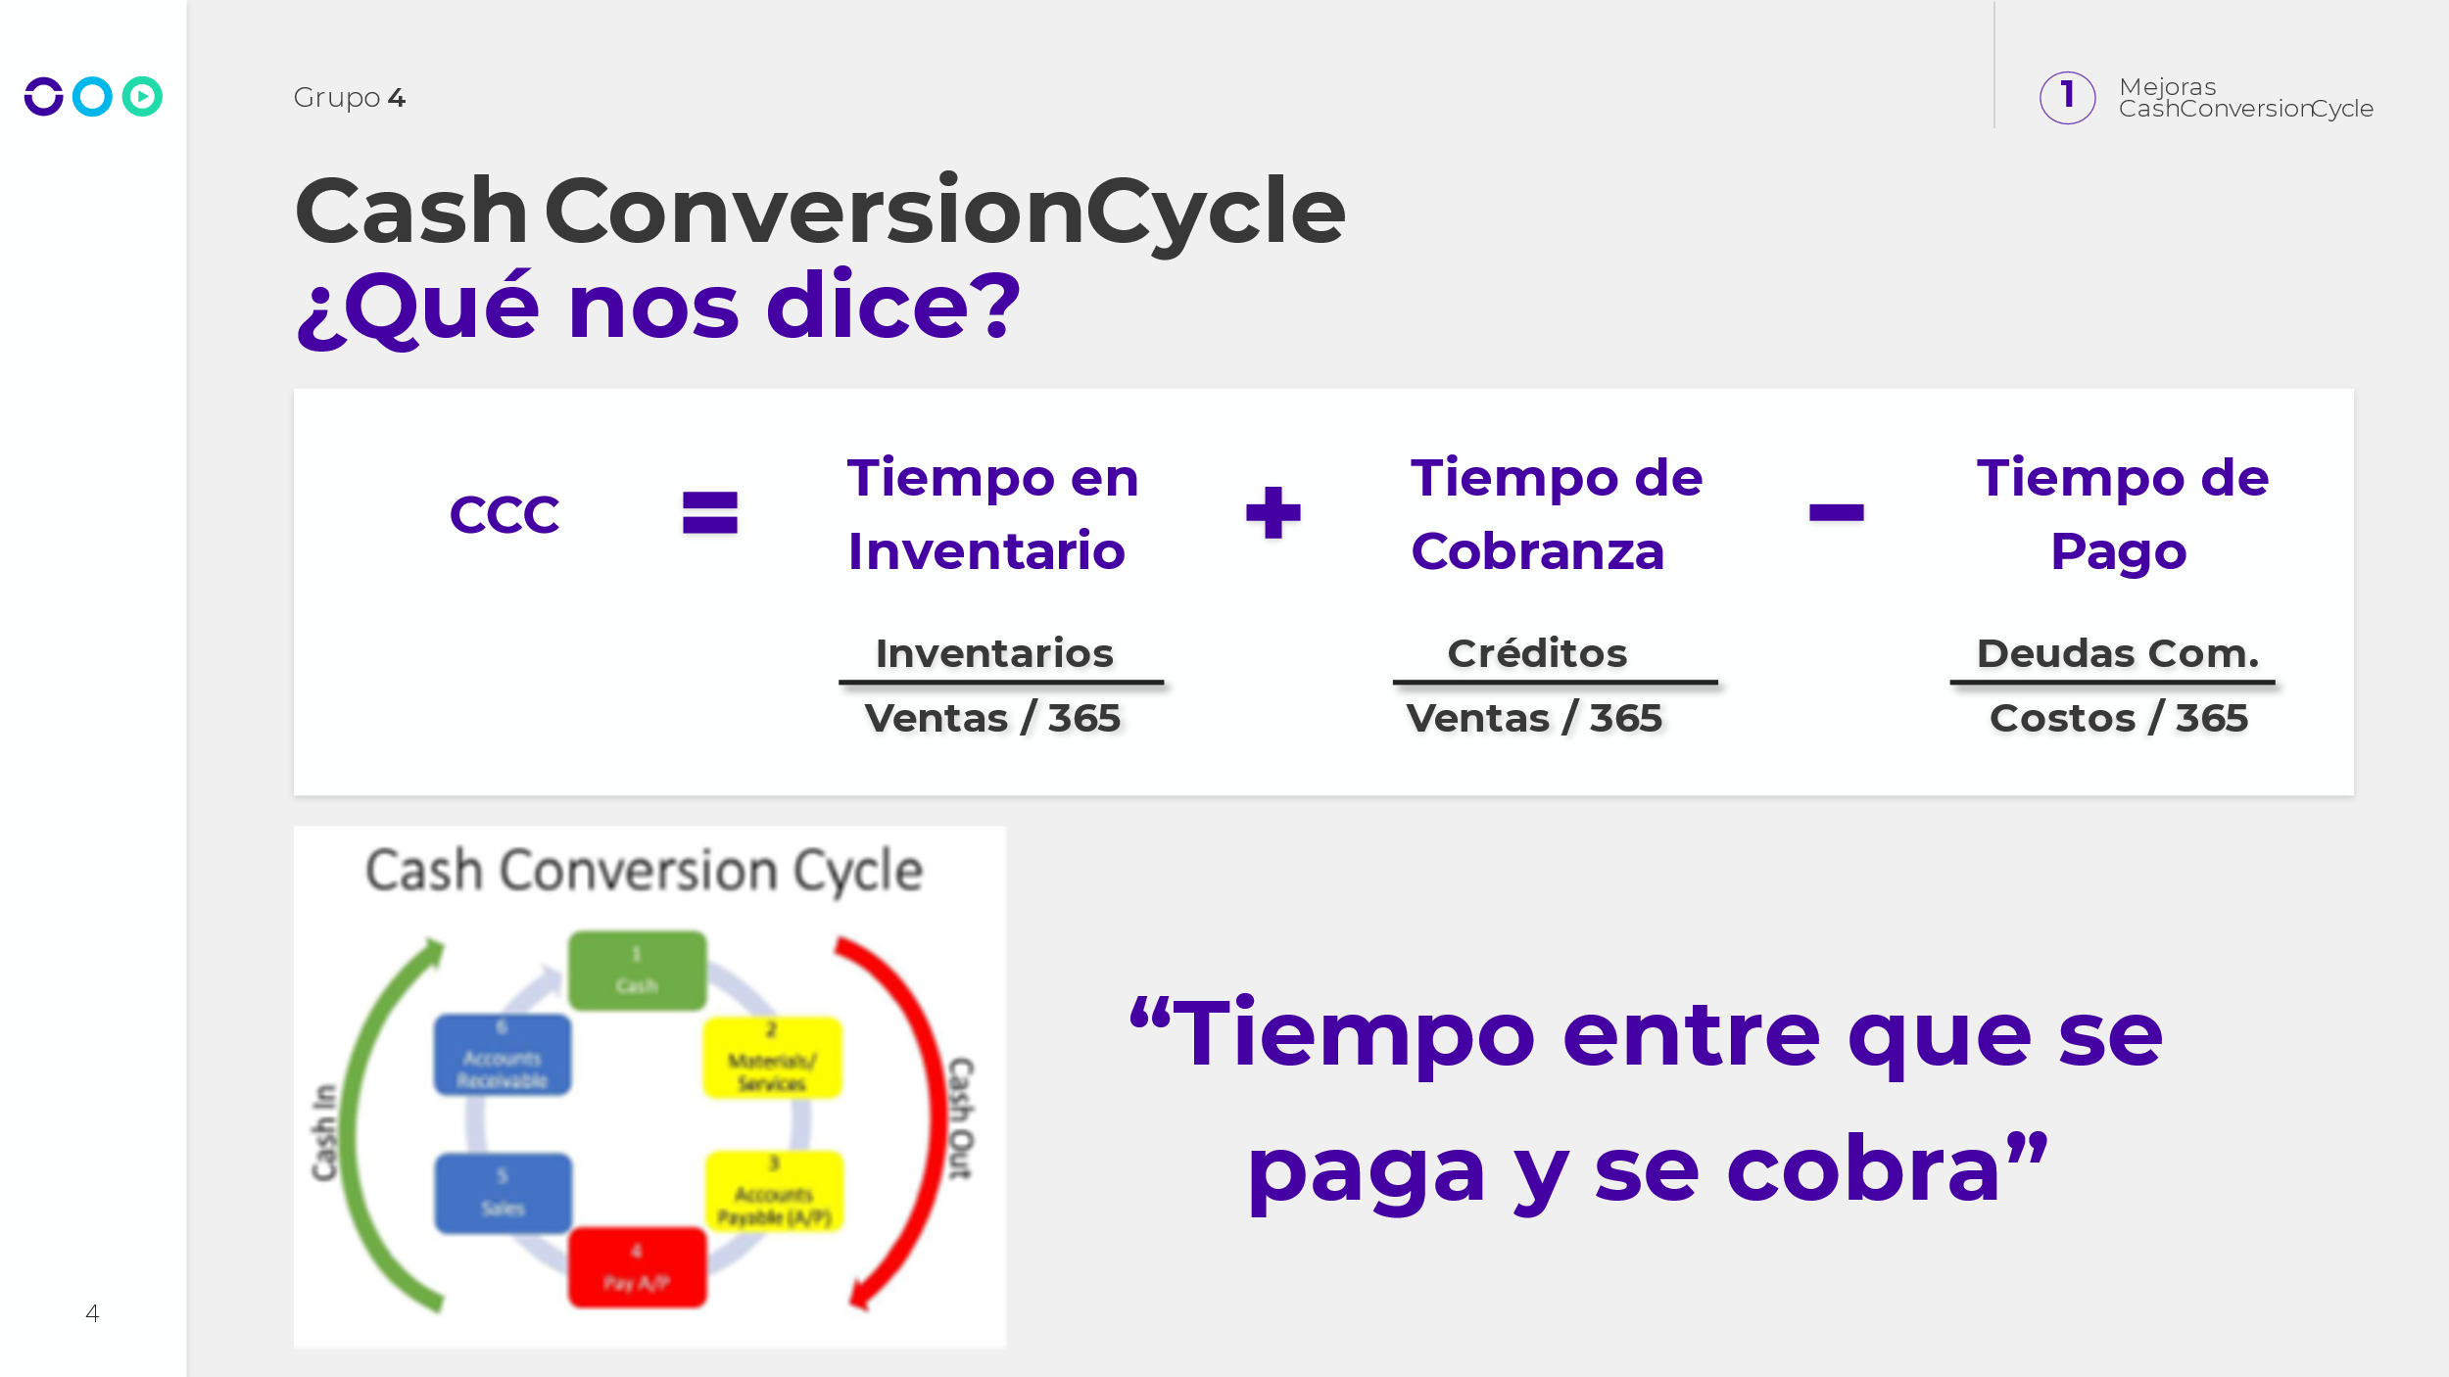

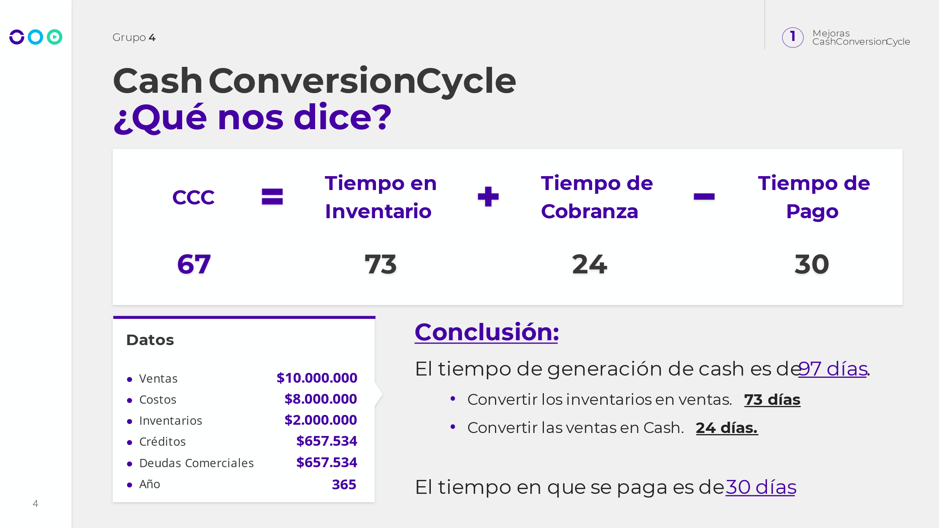

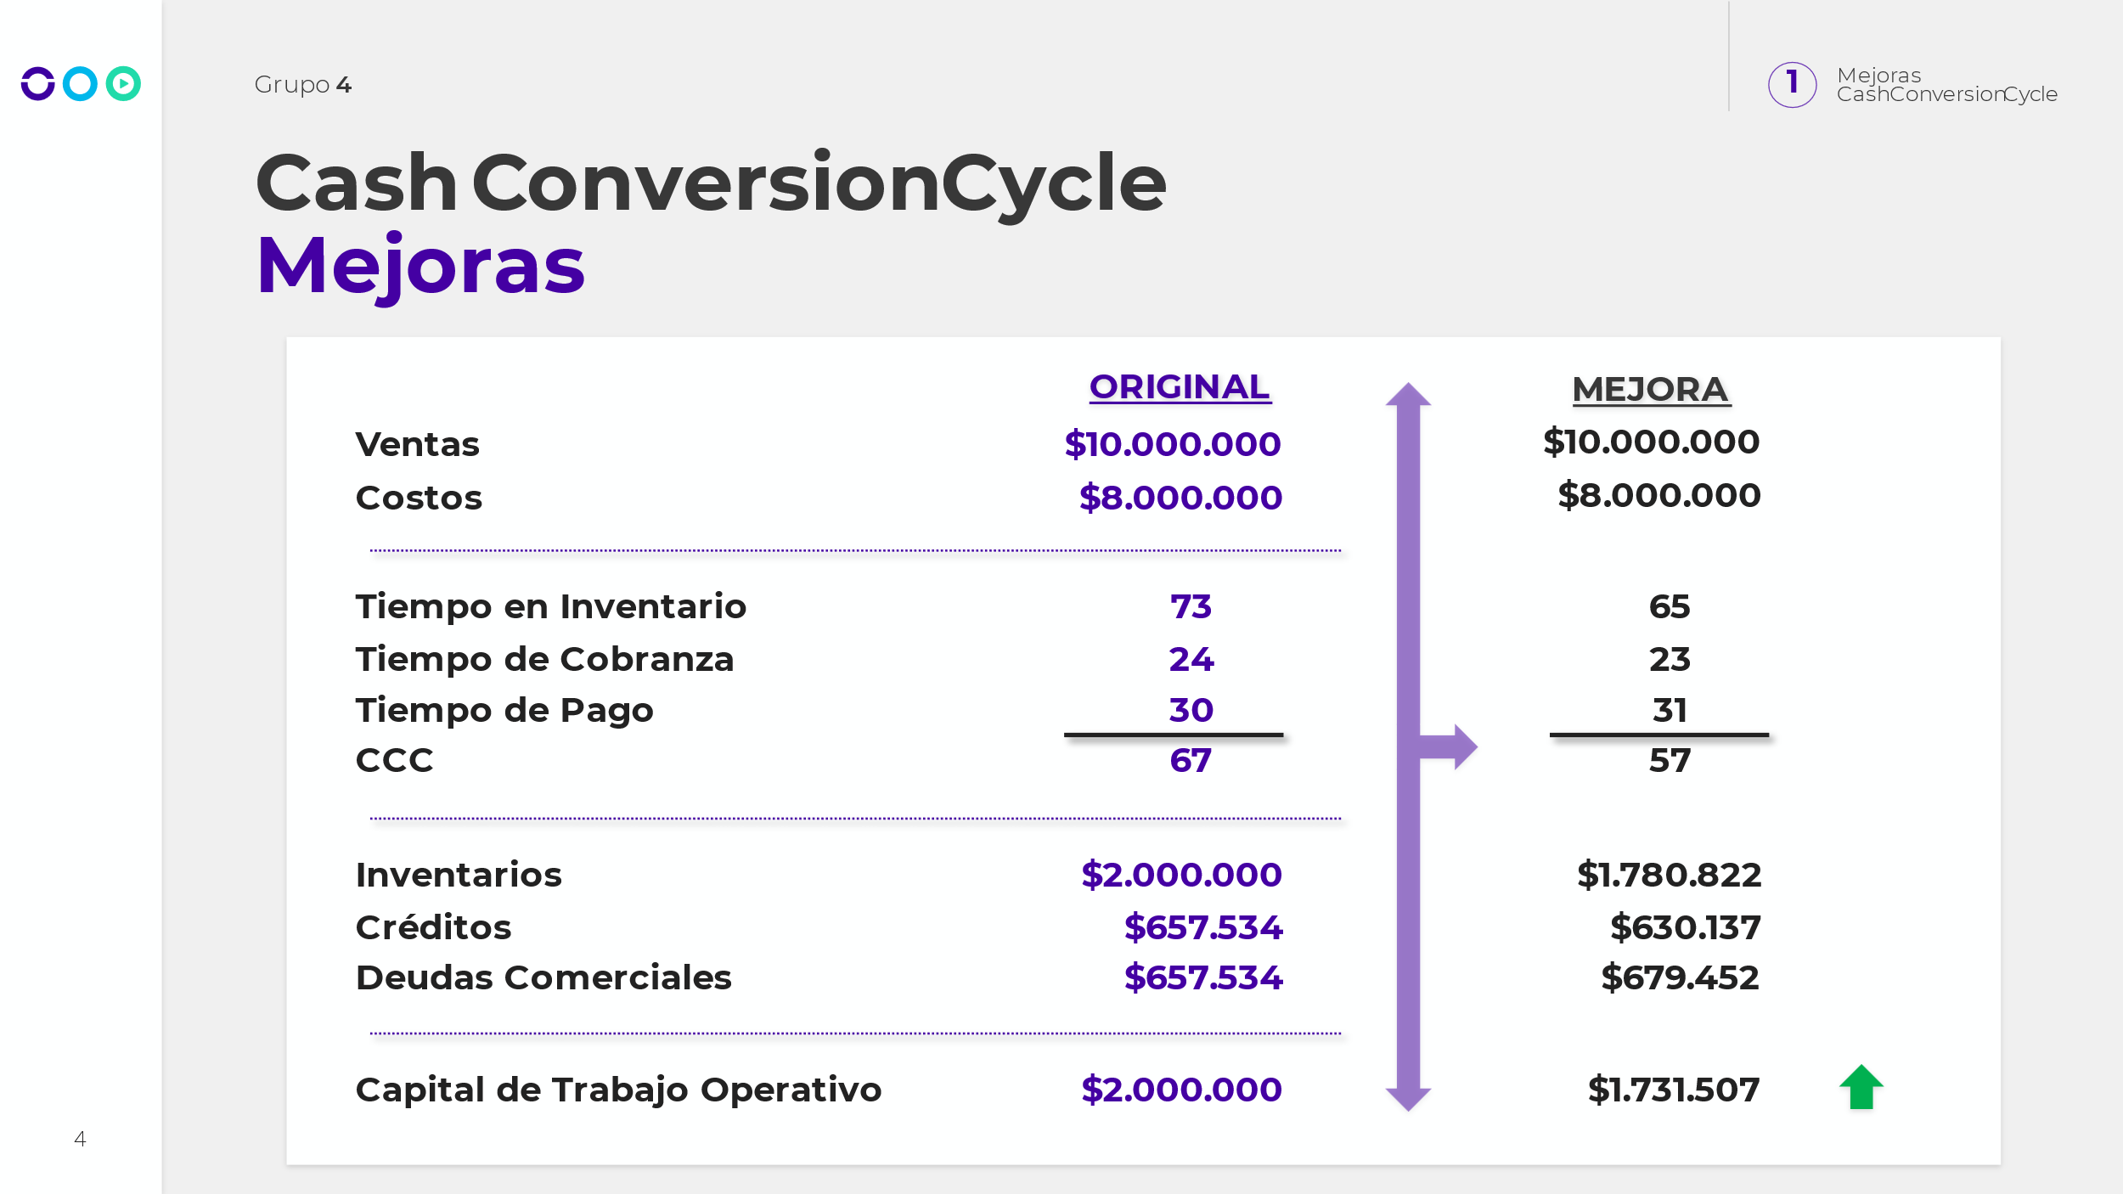

El Cash Conversion Cycle (Ciclo de Conversión de Efectivo) es un indicador de la eficiencia de la gestión de la cadena de suministro de una empresa, que mide el tiempo que transcurre desde que se invierte dinero en la producción de bienes o servicios hasta que se recupera ese dinero a través de las ventas.

En términos generales, cuanto más corto sea el ciclo de conversión de efectivo, mejor será para la empresa, ya que podrá recuperar su inversión más rápidamente y tendrá más liquidez para financiar sus operaciones y proyectos futuros.

En la tabla proporcionada, se muestra que la mejora de la empresa en el Ciclo de Conversión de Efectivo de 67 días a 57 días, indica que la empresa ha sido capaz de acelerar el proceso de conversión de efectivo, lo que significa que ha mejorado su eficiencia en la gestión de sus inventarios, cuentas por cobrar y cuentas por pagar.

Esto, a su vez, puede traducirse en una mayor rentabilidad y valor para la empresa, ya que podrá utilizar sus recursos de manera más eficiente y tendrá más capacidad para reinvertir en su negocio y hacer crecer su empresa. Además, un ciclo de conversión de efectivo más corto también puede ser percibido por los inversores como un signo de una gestión empresarial sólida y una empresa financieramente saludable, lo que puede mejorar la imagen y la reputación de la empresa en el mercado.

* Hay que pronosticar las necesidades de caja de corto y por eventualidades.
* Flujo neto: Flujos entrantes - Flujos salientes.
* No incluir amortizaciones.

Ojo con impuestos. Mas amortización, menos impuestos por deducciones. Afecta caja. Una caja deficiente puede afectar negativamente la gestión de una empresa en varias situaciones, entre ellas:

1. Incapacidad para cumplir con las obligaciones de pago: Si la empresa no cuenta con suficiente efectivo para pagar sus deudas a tiempo, puede incurrir en costos financieros adicionales, como intereses y penalizaciones por pagos tardíos.
2. Pérdida de oportunidades de inversión: Si la empresa no tiene suficiente efectivo disponible para aprovechar oportunidades de inversión rentables, como la adquisición de un activo valioso o la expansión a nuevos mercados, puede perder ventaja competitiva.
3. Falta de liquidez: Si la empresa no tiene suficiente efectivo disponible para financiar sus operaciones diarias, puede tener dificultades para mantener su negocio en funcionamiento y puede incurrir en costos adicionales para obtener financiamiento a corto plazo.
4. Pérdida de confianza de los inversionistas: Si la empresa no tiene una buena gestión de su caja y experimenta problemas financieros, puede perder la confianza de sus inversionistas y reducir su acceso a financiamiento futuro.

En resumen, una caja deficiente puede afectar la capacidad de una empresa para cumplir con sus obligaciones financieras, aprovechar oportunidades de inversión, mantener su negocio en funcionamiento y mantener la confianza de sus inversionistas. Por lo tanto, es importante que las empresas planifiquen cuidadosamente su gestión de caja para evitar problemas financieros y garantizar su éxito a largo plazo.

* No es lo mismo un mal mes de ventas vs un bache de caja. Este ultimo tiene un arrastre. Podes vender mucho y tener faltante de caja.



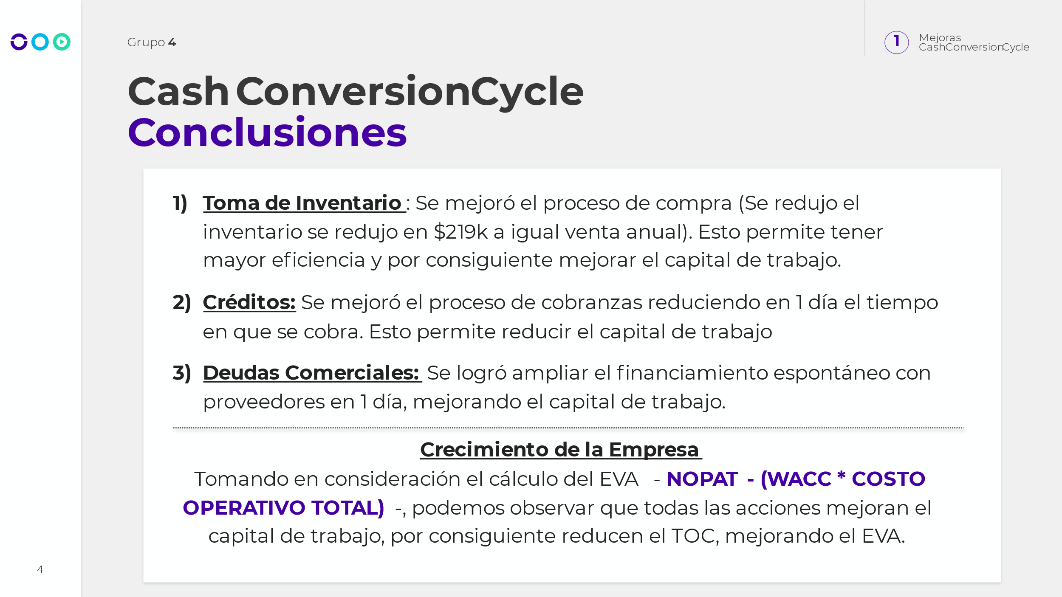

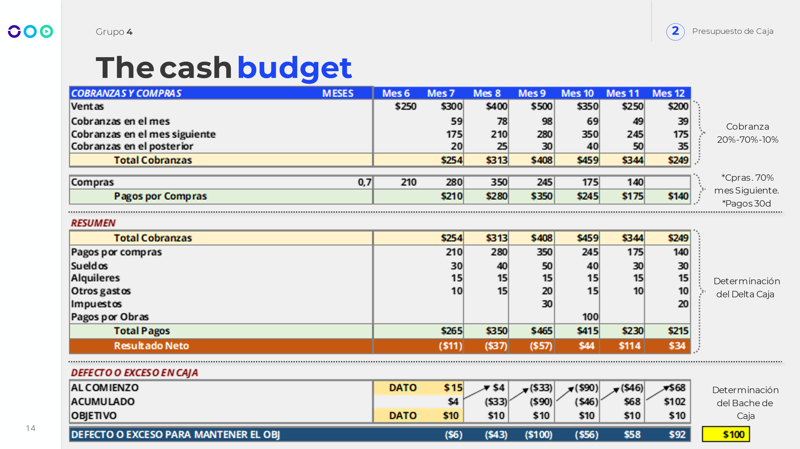

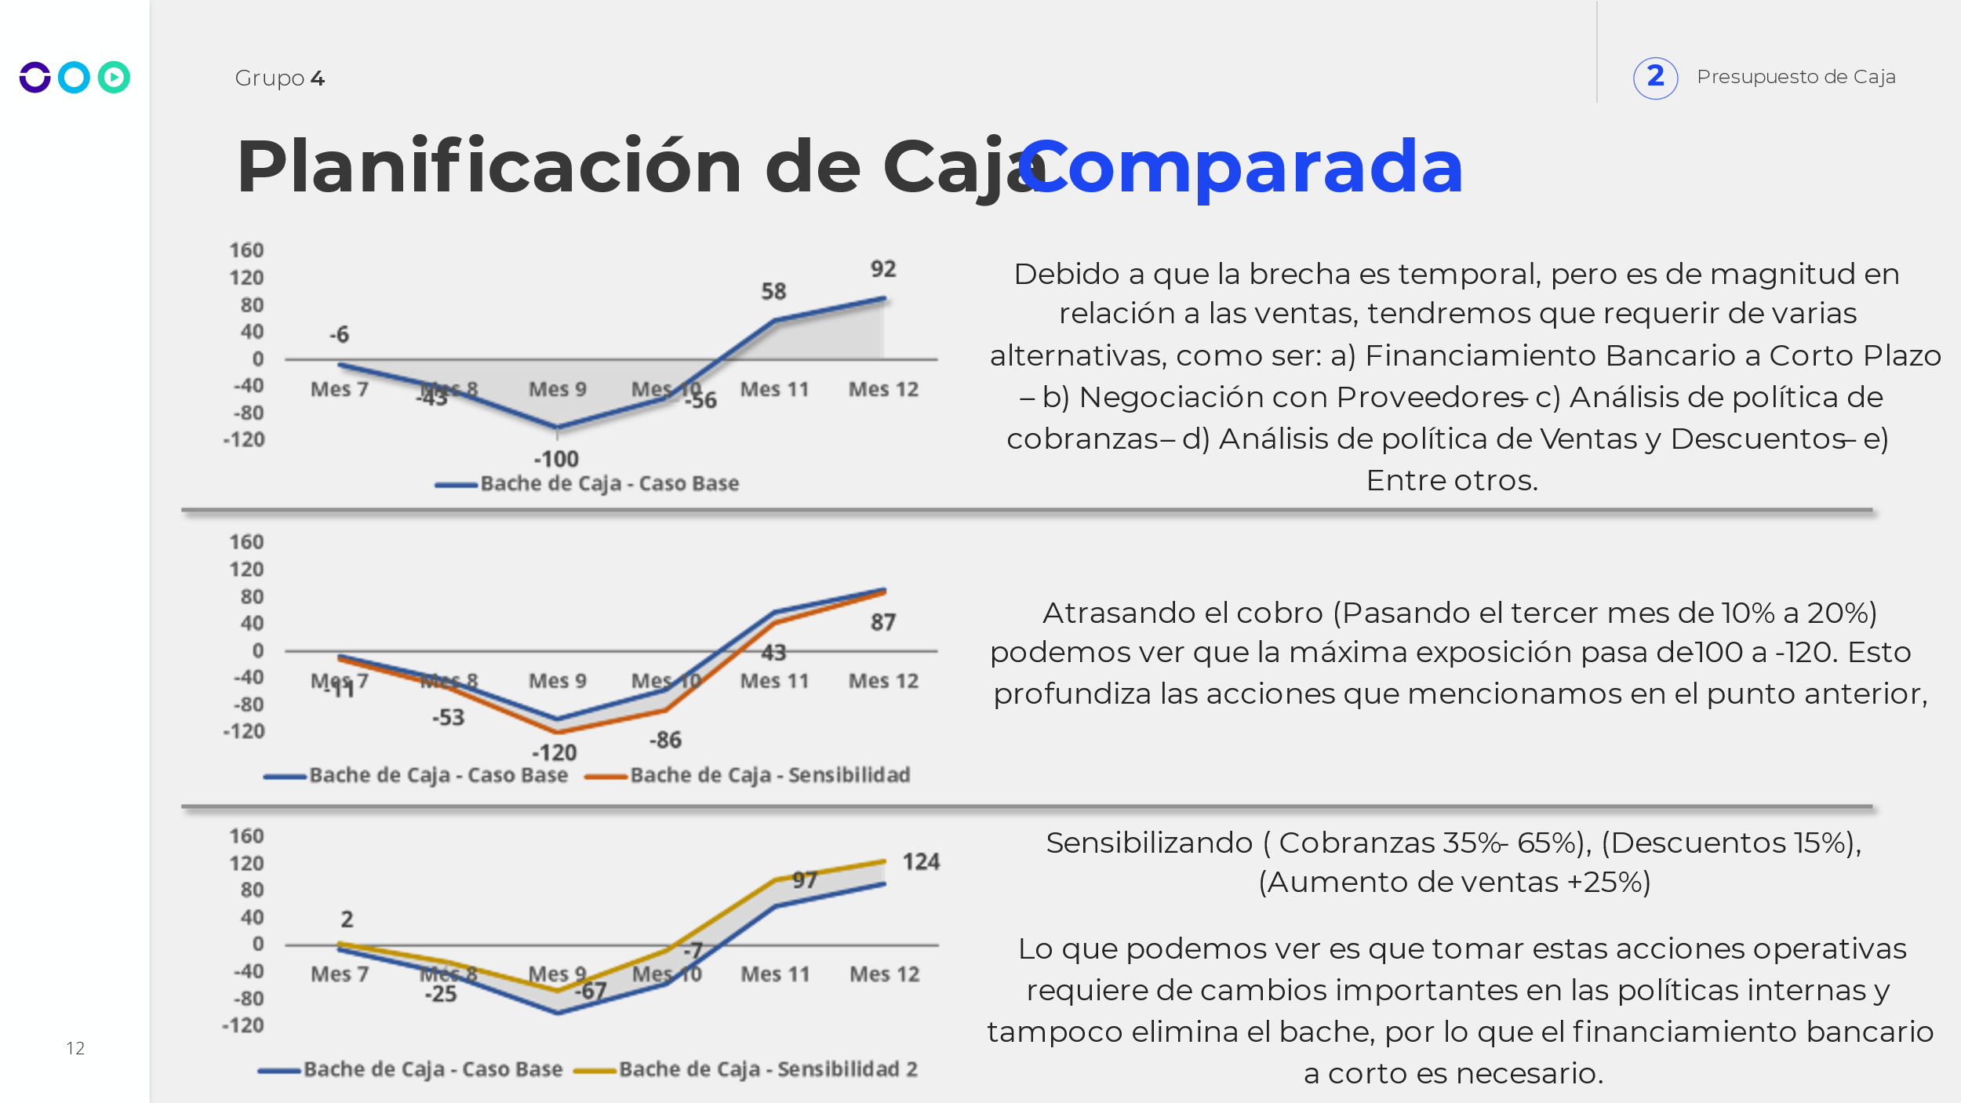



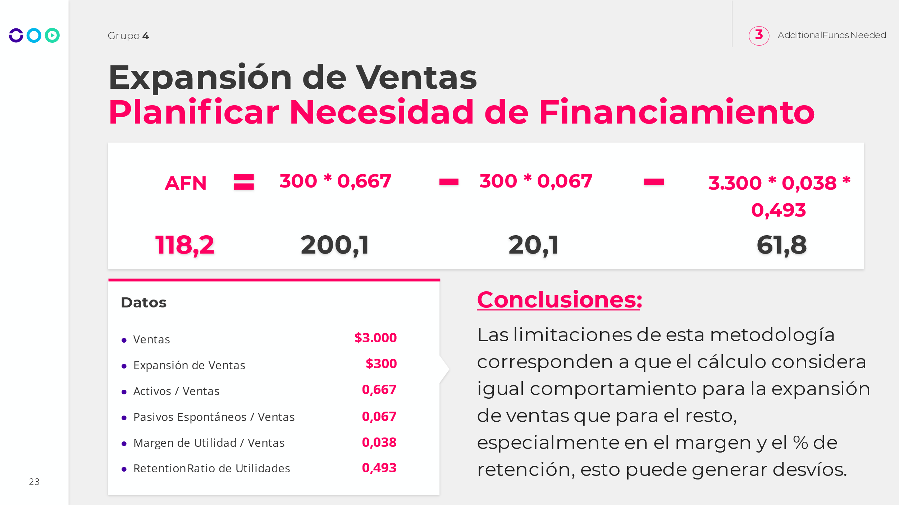

Como se calcula:

El activo se relaciona en que el valor depende del incremento de los activos respecto de las ventas.

Un incremento del activo tiene impacto en PN y pasivo.

Simplemente por crecer pasan dos cosas

1. Financiacion espontanea (-), mayores deudas comerciales
2. Gano mas dinero(-), tenes mas plata para distribuir.

Este ultimo sirve para financiar la expansion

1. Ir afuera a buscar plata (+)

AFN (3) additional funds needed.

AFN = mayor activo - expansion por financiamiento - utilidades que genero por expansión



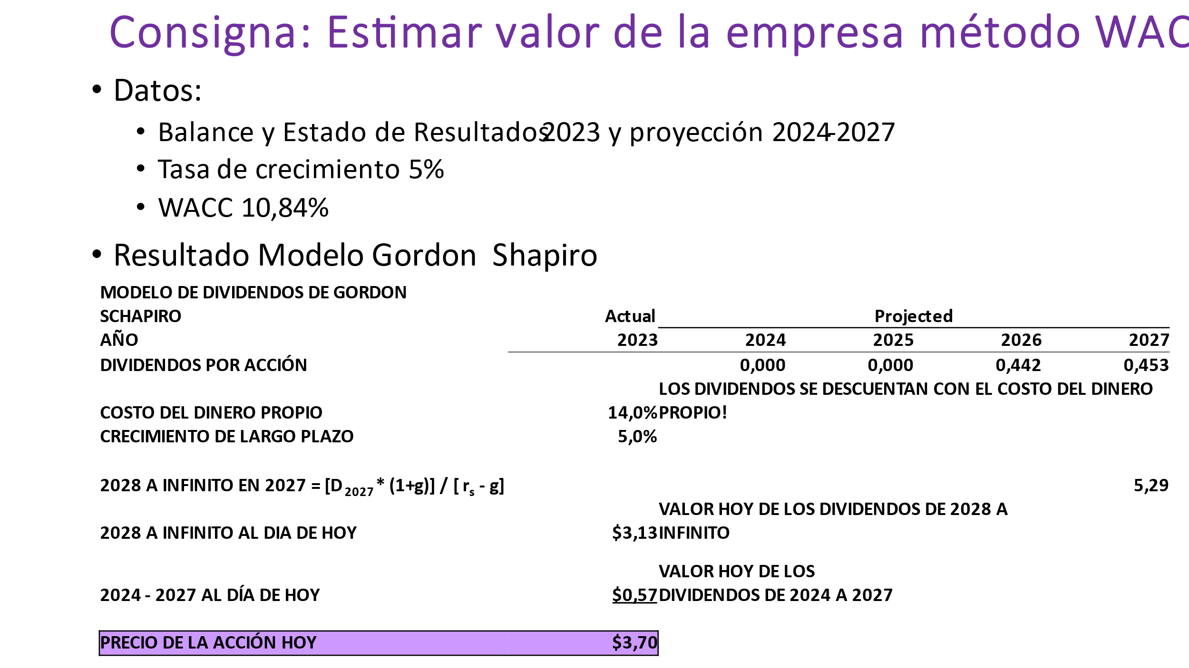

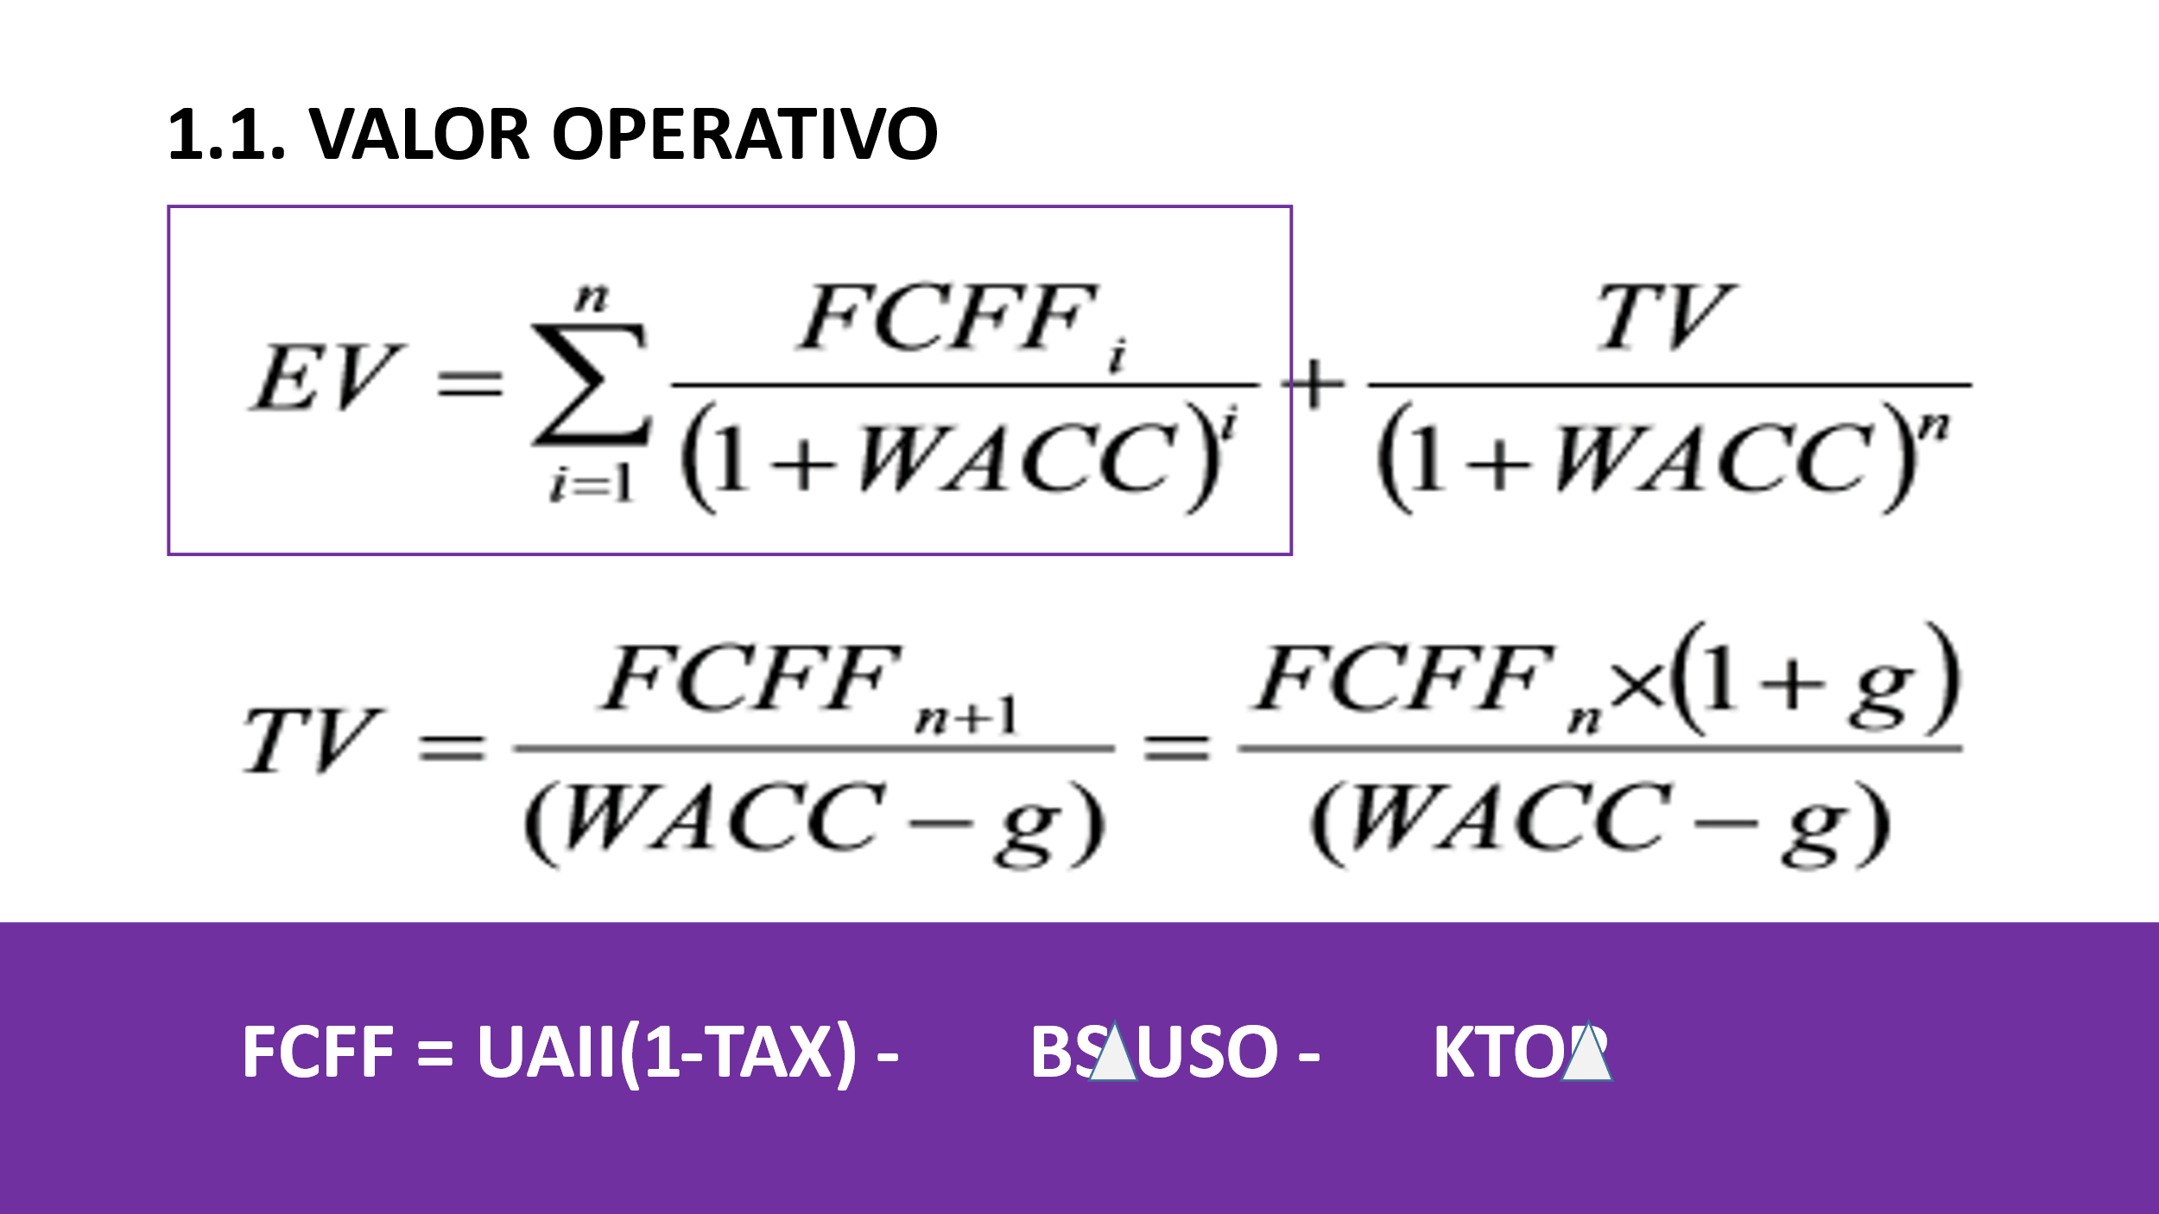

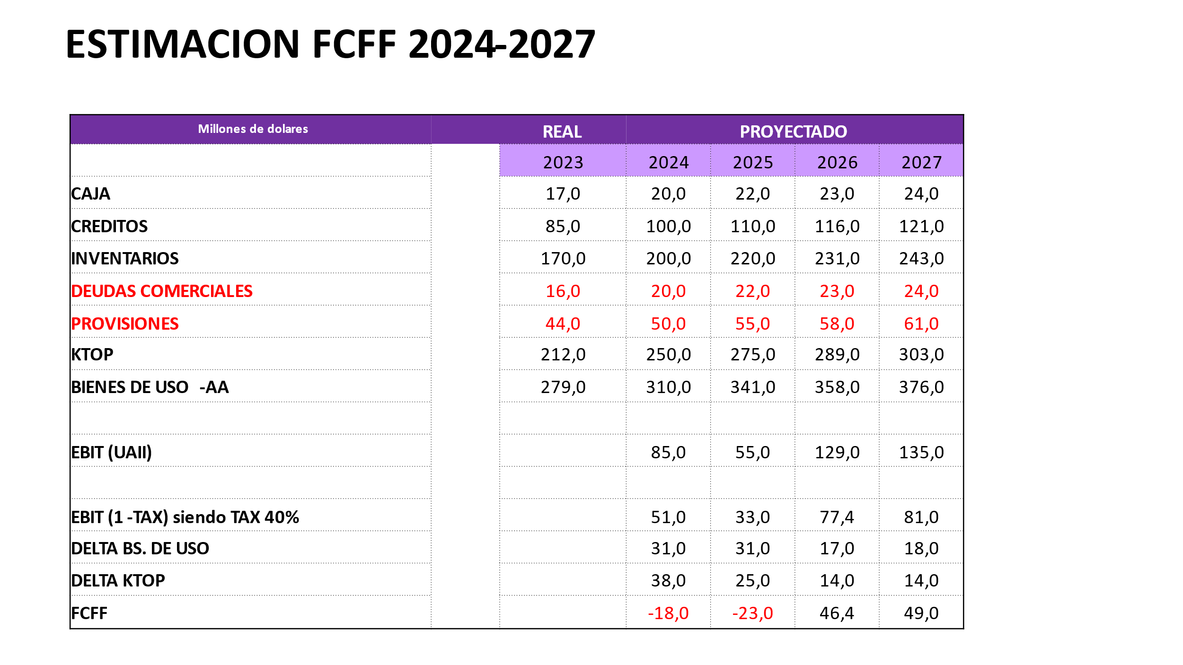

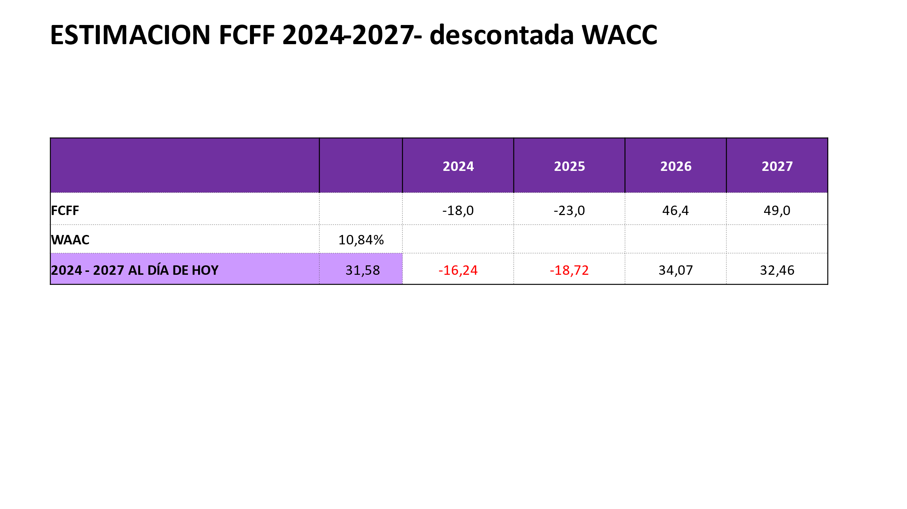

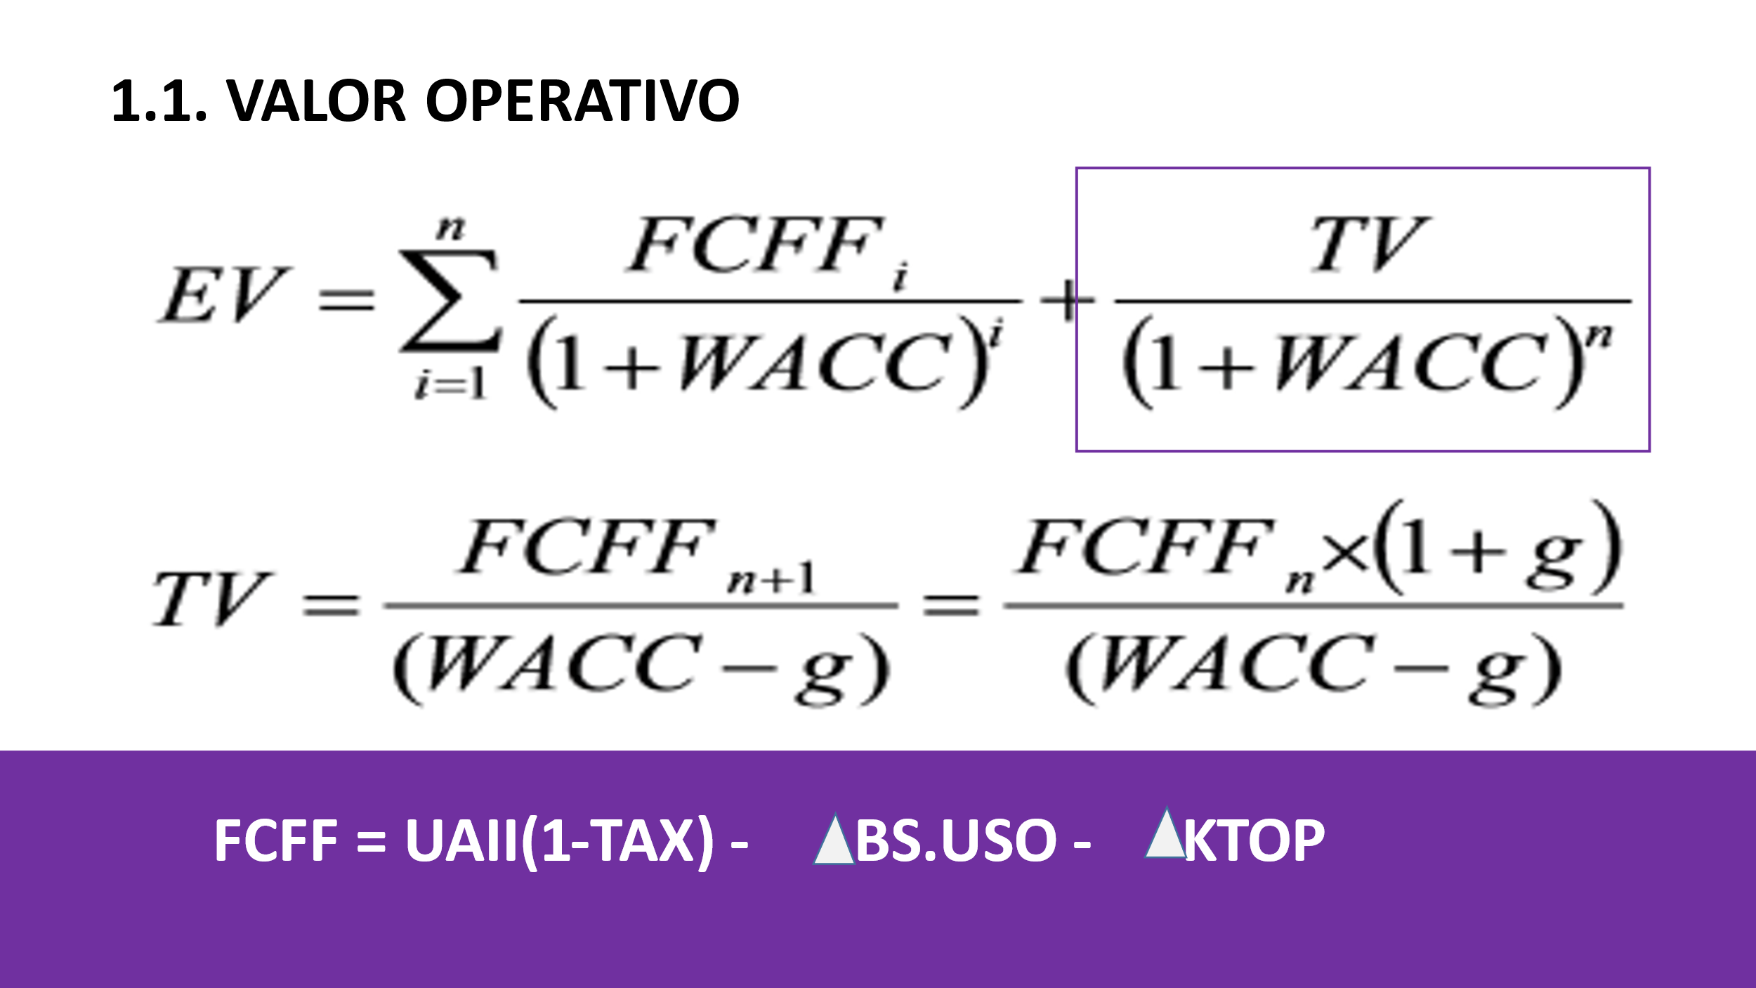

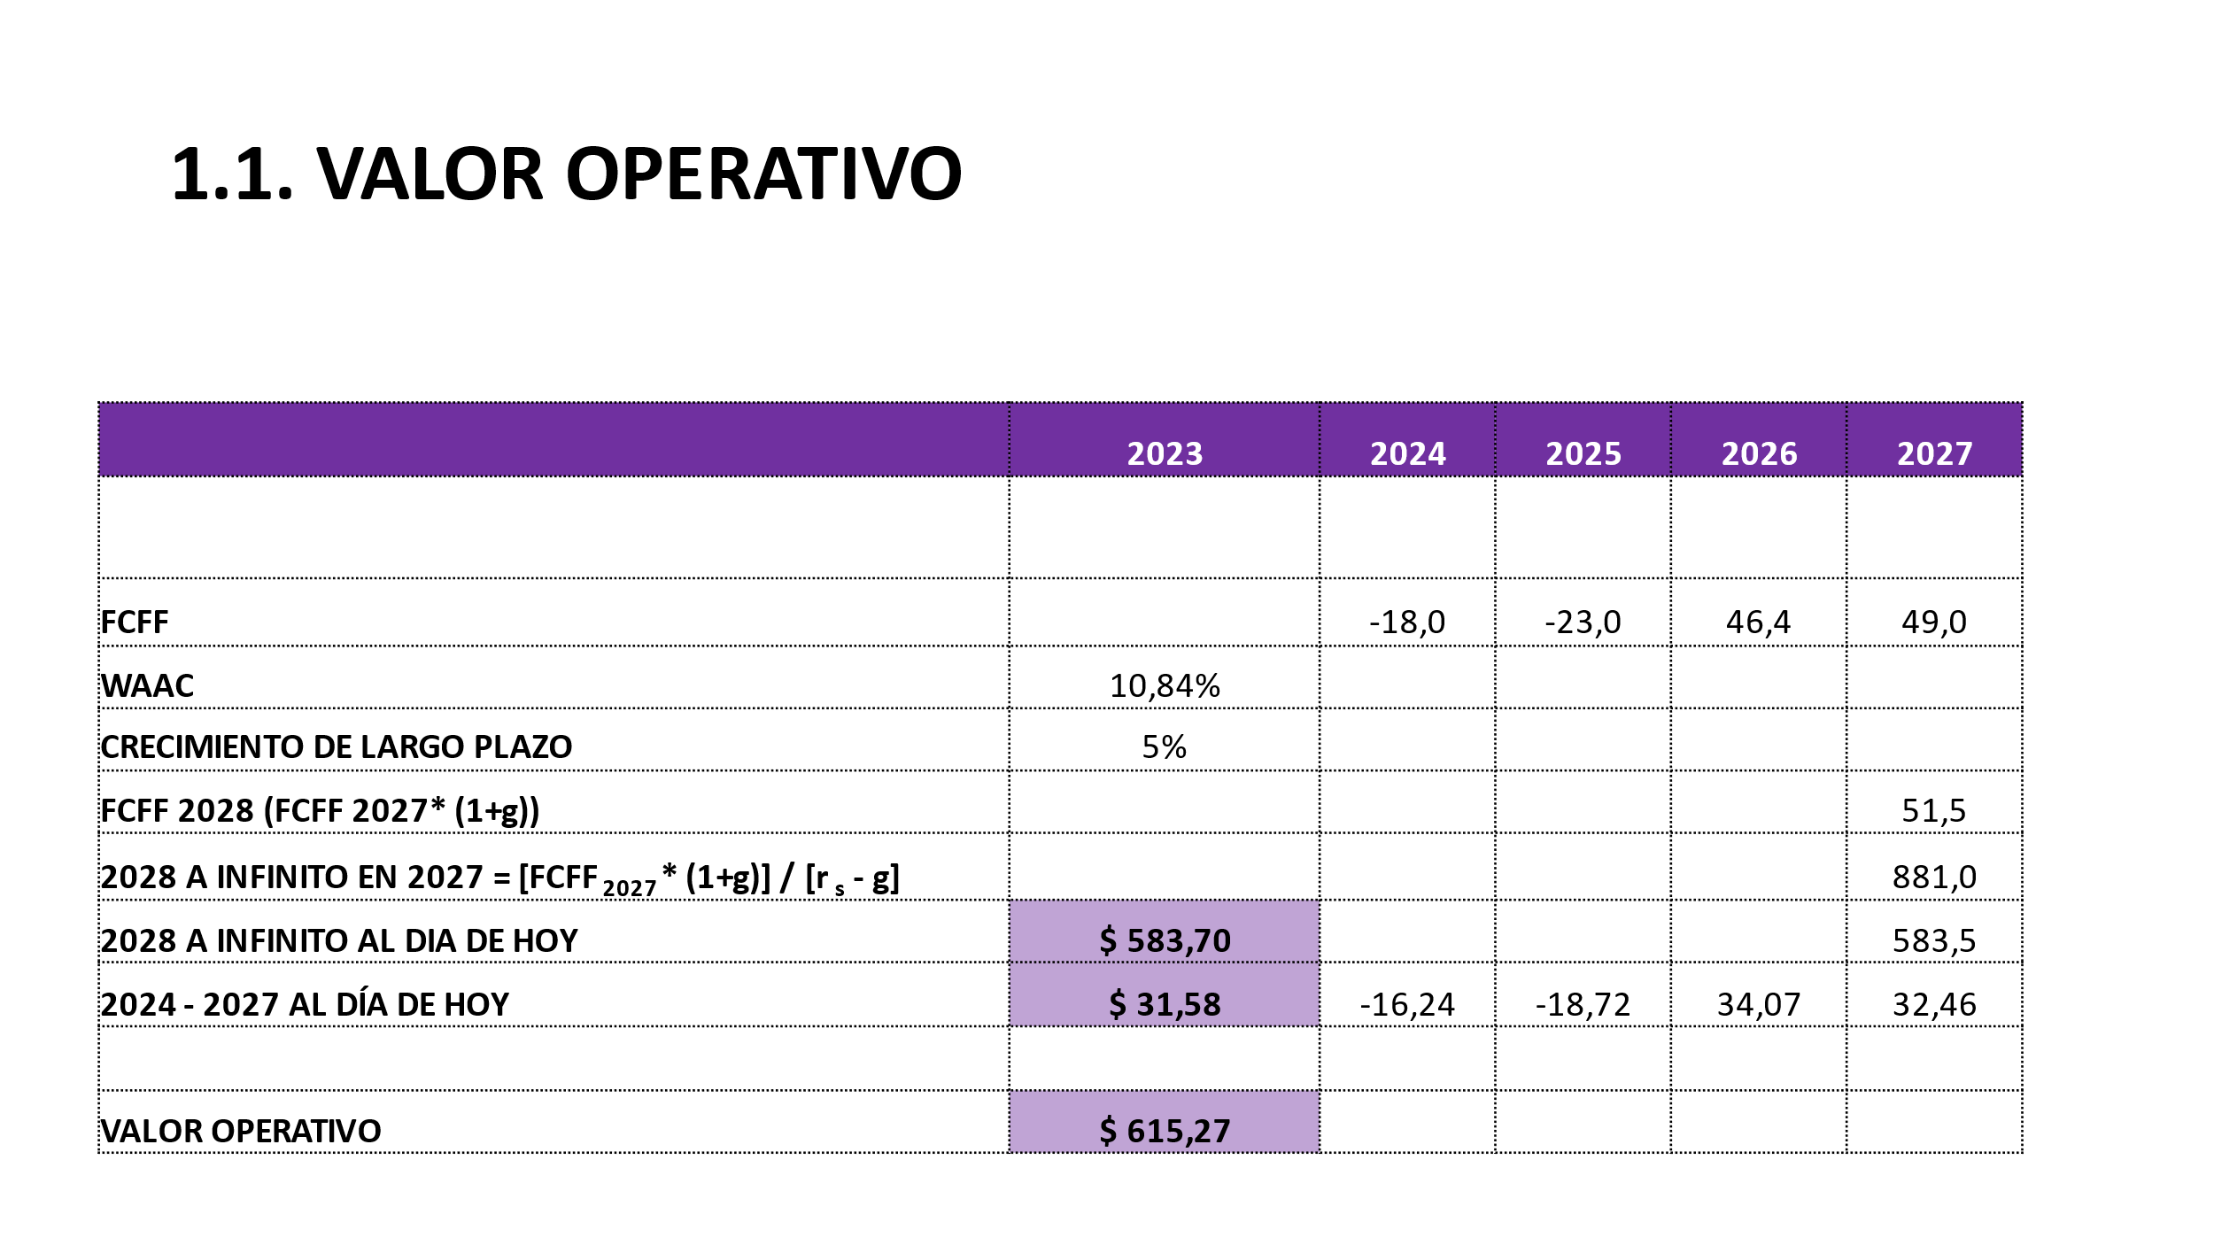

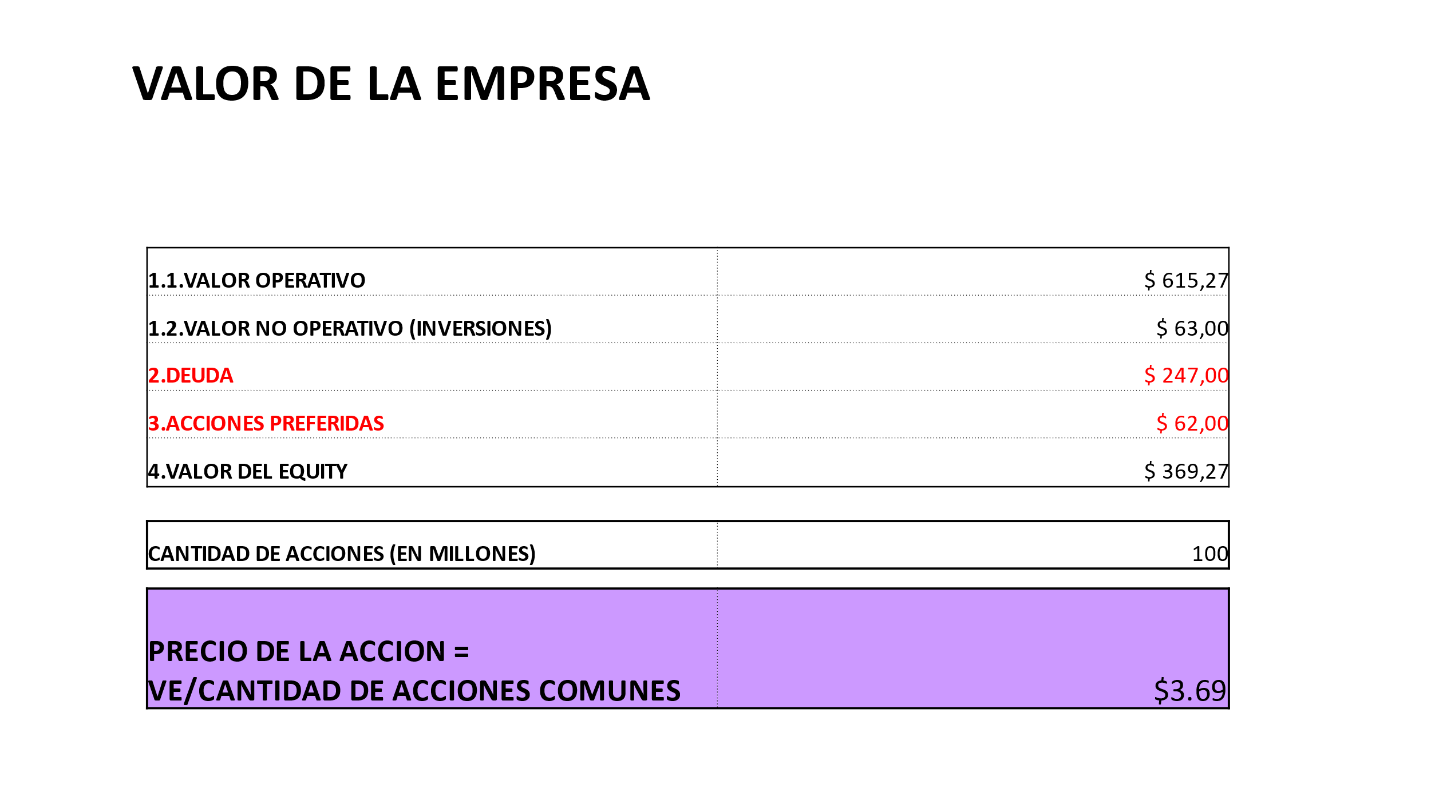

## What Is Enterprise Value (EV)?

Enterprise value (EV) measures a company's total value, often used as a more comprehensive alternative to [market capitalization](https://www.investopedia.com/terms/m/marketcapitalization.asp). EV includes in its calculation the market capitalization of a company but also short-term and long-term debt and any cash or cash equivalents on the company's balance sheet.

### KEY TAKEAWAYS

* Enterprise value (EV) measures a company's total value, often used as a more comprehensive alternative to equity market capitalization.
* Enterprise value includes in its calculation the market capitalization of a company but also short-term and long-term debt and any cash on the company's balance sheet.
* Enterprise value is used as the basis for many financial ratios that measure a company's performance.
* The equation EV = FCFF + TV is used in corporate finance and represents the enterprise value (EV) of a company. It states that the enterprise value is equal to the present value of the expected future cash flows, which are the free cash flows to the firm (FCFF), plus the present value of the expected future terminal value (TV).
* FCFF refers to the cash flow available to a company's investors after all operating expenses, taxes, and capital expenditures have been paid. This metric is used to determine the cash flow that a company generates from its operations and is available to its investors.
* TV represents the value of a company's future cash flows beyond the forecast period. It is typically calculated using a perpetuity formula or by applying a multiple to a projected future year's cash flow.
* By adding the present value of the expected FCFF and TV, the enterprise value can be determined. This formula is commonly used in corporate finance for company valuation and analysis.

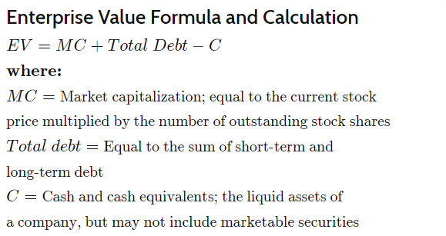

Preferred shares are**not included in your standard market cap calculation** because their characteristics are more like debt, thus equity value to common shareholders is reduced by amounts owed to preferred shareholders.

Negocios con mucha deuda tienen mayor valor.

Negocios con mucho cash y poca deuda tiene mayor valor de equity

Enterprise value no hace diferencia entre el valor de deuda y equity, como tampoco de la estructura de capital o como se financia. Es “unlevered”. Este sería el purchase Price.

El equity value es el valor fuera de la deuda. Primero devuelvo a los acreedores. Es el valor que le interesa a los accionistas

EqV = EntV – Deuda + Cash

Using the formula for Enterprise Value that you gave earlier:

Enterprise Value = Present Value of FCFF + Cash and Cash Equivalents - Debt and Other Non-Equity Claims

To calculate equity value from FCFF, you need to subtract Debt and Other Non-Equity Claims from the Enterprise Value and then add Cash and Cash Equivalents.

So the formula for Equity Value would be:

Equity Value = Enterprise Value - Debt and Other Non-Equity Claims + Cash and Cash Equivalents

Where:

* Enterprise Value = Present Value of FCFF + Cash and Cash Equivalents - Debt and Other Non-Equity Claims
* Debt and Other Non-Equity Claims = the outstanding value of any debt, preferred stock, or other non-equity claims on the company's cash flows.
* Cash and Cash Equivalents = the value of cash and highly liquid investments owned by the company.

This formula will give you the equity value of the company based on the FCFF approach.

